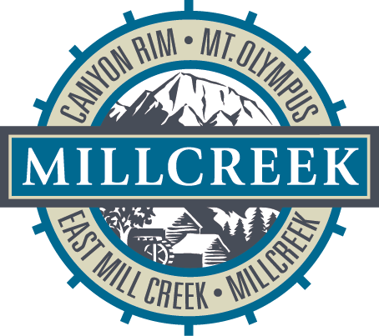

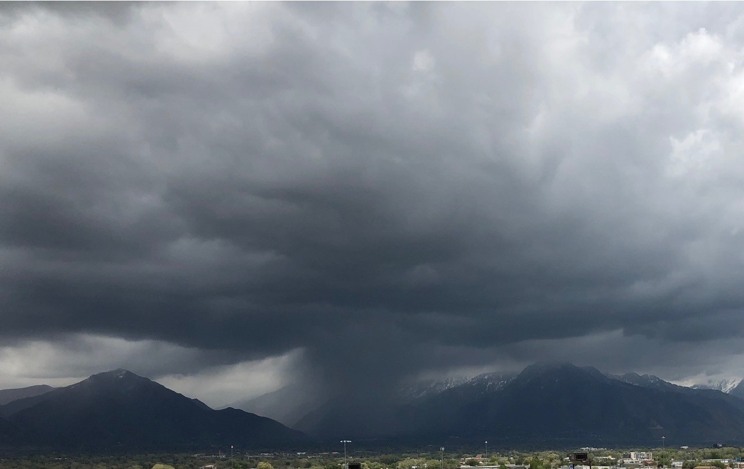
MILLCREEK
STORMWATER MANAGEMENT PLAN
2020-2025
TABLE OF CONTENTS ii-vi
LIST OF TABLES iv
LIST OF FIGURES iv
LIST OF APPENDICES v
LIST OF ACRONYMS vi

- CERTIFICATION 1

- STORMWATER MANAGEMENT PLAN INTRODUCTION 2
  - SWMP COORDINATION 2
  - PURPOSE 6
  - SWMP REVIEW AND MODIFICATION 6
  - STAFFING AND RESOURCE ALLOCATION 6
  - PROGRAM SUMMARY 7

- SPECIAL CONDITIONS 11
  - DISCHARES TO IMPAIRED WATERS 11
  - NITROGEN AND PHOSPHOROUS REDUCTIONS 12
  - POLLUTANTS OF CONCERN……………………………………………………………………12

- PUBLIC EDUCATION AND OUTREACH ON STORMWATER IMPACTS 13
  - SUMMARY OF TASKS 13
    - RESIDENTS EDUCATION PROGRAM 13
    - INSTITUTIONS, INDUSTRIAL AND COMMERCIAL FACILITIES EDUCATION PROGRAM 15
    - DEVELOPERS AND CONTRACTORS EDUCATION PROGRAM 15
    - MS4 OWNED OR OPERATED FACILITIES 15
    - EVALUATE EFFECTIVENESS OF PUBLIC EDUCATION AND OUTREACH PROGRAMS 16
    - SALT LAKE COUNTY STORMWATER COALITION 16
  - GOALS AND ASSESSMENTS 17

- PUBLIC INVOLVEMENT/PARTICIPATION 19
  - SUMMARY OF TASKS 19
    - PUBLIC INVOLVEMENT 19
    - PUBLIC PARTICIPATION 19
    - PUBLIC SURVEY 19
  - GOALS AND ASSESSMENTS 20

- ILLICIT DISCHARGE DETECTION AND ELIMINATION (IDDE) 22
  - SUMMARY OF TASKS 22
    - ILLICIT DISCHARGE DETECTION AND ELIMINATION PLAN ORDINANCE 22
    - MAPPING 22
    - ILLICIT DISCHARGE DETECTION AND ELIMINATION PLAN 23
    - PROGRAM EVALUATION AND ASSESSMENT 25
    - ILLICIT DISCHARGE DETECTION AND ELIMINATION TRAINING 25
  - GOALS AND ASSESSMENTS 26
- CONSTRUCTION SITE STORMWATER RUNOFF CONTROL PROGRAM 28
  - SUMMARY OF TASKS 28
    - CONSTRUCTION SITE STORMWATER RUNOFF CONTROL ORDINANCE 28
    - PRE-CONSTRUCTION REVIEWS 29
    - CONSTRUCTION SITE INSPECTIONS & ENFORCEMENT 29
    - CONSTRUCTION SITE STORMWATER TRAINING 30
    - RECORDS KEEPING 30
  - GOALS AND ASSESSMENTS 31

- LONG-TERM STORMWATER MANAGEMENT IN NEW DEVELOPMENT AND
REDEVELOPMENT PROGRAM 33
  - SUMMARY OF TASKS 33
    - POST-CONSTRUCTION CONTROLS 33
    - LONG-TERM STORMWATER MANAGEMENT ORDINANCE 34
    - IMPLEMENT LONG-TERM STORMWATER BMPs 34
    - SITE PLAN REVIEW PROCEDURES 35
    - LONG-TERM STORMWATER MANAGEMENT INSPECTIONS AND
ENFORCEMENT 36
    - LONG-TERM STORMWATER BMP EMPLOYEE TRAINING 36
    - LONG-TERM STORMWATER BMP INVENTORY 37
8.2 GOALS AND ASSESSMENTS 37

- POLLUTION PREVENTION & GOOD HOUSEKEEPING FOR MUNICIPAL
OPERATIONS 39
  - SUMMARY OF TASKS 39
    - MUNICIPAL MAINTENANCE 39
    - FACILITY INVENTORY 40
    - MILLCREEK CONSTRUCTION PROJECTS 40
    - EMPLOYEE TRAINING 40
  - GOALS AND ASSESSMENTS 41

10.0 RECORDKEEPING, REPORTING, AND RESPONSIBILTY AGREEMENTS 42
10.1 SUMMARY OF TASKS 42
10.1.1 RECORDKEEPING 42
10.1.2 REPORTING 42
10.1.3 RESPONSIBILITY AGREEMENTS 43
10.2 GOALS AND ASSESSMENTS 43

LIST OF TABLES

Table 1 Impaired Waterbodies in Salt Lake County 11
Table 2 Public Education & Outreach Program Goals and Assessment 17
Table 3 Public Involvement/Participation Program Goals and Assessment 21
Table 4 Illicit Discharge Detection & Elimination Program Goals and Assessment 26
Table 5 Construction Site Runoff Control Program Goals and Assessment 31
Table 6 Long-term Stormwater Management Program Goals and Assessment 38
Table 7 Pollution Prevention/Good Housekeeping Program Goals and Assessment 41
Table 8 Recordkeeping, Reporting and Responsibility Agreements Program Goals and Assessment 43

LIST OF FIGURES

Figure 1 Vicinity Map 3
Figure 2 Millcreek Waterways and Storm Drain System Maps 4
Figure 3 Organization Flow Chart 5

APPENDICES 44 to end

APPENDIX A 44
SWMP Modifications

APPENDIX B 45
ORDINANCES
MILLCREEK TITLE 17, Chapter 17.22
County Health Department #13 & #14
UAC R317-1.9

APPENDIX C ILLICIT DISCHARGE DETECTION AND ELIMINATION
PROGRAM 46 to 57
IDDE Plan with Dry Weather Screening Plan

APPENDIX D CONSTRUCTION SITE STORMWATER RUNOFF CONTROL
PROGRAM 58 to 78
Pre-Construction, Pre-SWPPP & SWPPP Review Site Inspections & Enforcement SOP
DWQ Construction Stormwater Inspection Form
Maintenance Agreement

APPENDIX E LONG-TERM STORMWATER MANAGEMENT PROGRAM
(IN DEVELOPMENT AND UNDER REVIEW) 79 to 83
Inspection SOP
Enforcement SOP (see Pre-construction SOP-Appendix D)

APPENDIX F REPORTING & RESPONSIBILITY 84
DWQ Annual Report Form
Agreements/Responsibilities

LIST OF ACRONYMS

BMP Best Management Practice
County Salt Lake County
DWQ Utah Division of Water Quality
EPA Environmental Protection Agency
Engineering & FC Salt Lake County Engineering and Flood Control Services
IDDE Illicit Discharge Detection and Elimination
JRWC Jordan River Watershed Council
LID Low Impact Development
MEP Maximum Extent Practicable
Millcreek City of Millcreek
MS4 Municipal Separate Storm Sewer System
SHPO State Historic Preservation Office
SIC Standard Industrial Classification
SLCo HD Salt Lake County Health Department
SOP Standard Operating Procedure
SWMP Stormwater Management Plan
SWPPP Stormwater Pollution Prevention Plan
TMDL Total Maximum Daily Load
UAC Utah Administrative Code
UDOT Utah Department of Transportation
UPDES Utah Pollutant Discharge Elimination System
USWAC Utah Stormwater Advisory Committee

certification
In accordance with Part 2.3.2.8 and Part 6.8 of the permit, the following statement must be incorporated and signed in this document:

Certification Statement:
I certify under penalty of law that this document and all attachments were prepared with direction or supervision in accordance with a system designed to assure that qualified personnel properly gather and evaluate the information submitted. Based on my inquiry of the person or persons who manage the system, or those persons directly responsible for gathering the information, the information submitted is, to the best of my knowledge and belief, true, accurate, and complete. I am aware that there are significant penalties for submitting false information, including the possibility of fine and imprisonment for knowing violations.

Signature: ________________________________________________________

Printed Name: Mayor JEFF SILVESTRINI (or designee)
Date:

STORMWATER MANAGEMENT PLAN INTRODUCTION
Millcreek is an urban community and municipality within the Salt Lake Valley (Figure 1). The Millcreek stormwater system consists of local municipal drainage pipes, open channels, canals, or natural channels (Figure 2). Waterways in Millcreek include Mill Creek, Parleys Creek, Neff’s Creek, and Big Cottonwood Creek. The main conveyance system in the valley is the Jordan River, which flows from Utah Lake to the Great Salt Lake. Flood control facilities (including the major creeks) are operated and maintained by Salt Lake County’s Engineering and Flood Control Services. These facilities are defined in Chapter 17 of the Salt Lake County Code of Ordinances.
Millcreek received coverage from the Utah State Division of Water Quality (DWQ) under the Utah Pollutant Discharge Elimination System (UPDES) Stormwater Discharge Permit No. UTS000001 as a Phase II Co-Permittee of the Jordan Valley Municipalities Municipal Separate Storm Sewer System (MS4) on December 5, 2017. This permit https://documents.deq.utah.gov/water-quality/facilities/jordan-valley-municipalities/DWQ-2020-005244.pdf regulates the discharge of stormwater from Millcreek’s MS4 to water bodies of the State. The UPDES program falls under the purview of the Clean Water Act’s storm water permitting requirements in accordance with 40 CFR 122.32(a)(1).
This SWMP was developed to comply with the permit, and is designed to reduce, to the maximum extent practicable (MEP), the discharge of pollutants from the municipal storm drain system. The SWMP includes stormwater management practices, control techniques, system design and engineering methods, an education component, and other provisions appropriate for the control of pollutants. The development, implementation, and enforcement of the SWMP are to fulfill requirements under the permit, in accordance with Section 402(p)(3)(B) of the Federal Clean Water Act and State Storm Water Regulations (UAC R317-8-3.8).

SWMP COORDINATION

Millcreek, under the direction of its Engineering Services is responsible for the overall implementation of the SWMP. Other City agencies assist in this implementation as appropriate and as discussed in Section 2.4 and provided in the flow chart in Figure 3. Specific responsibilities are provided within each chapter. The responsible parties are as follows:

Agency: Millcreek, Engineering Services

Contacts: Mr. John Miller, PE, City Engineer,
Mr. Fredrick Lutze, PE, Deputy City Engineer
Mr. Dan Drumiler, PE, Stormwater Engineer/MS4 Program Manager
Mr. Aaron Roberts, Stormwater Program Lead
Mr. Deejay Allen, Stormwater and Construction Inspector
Mr. Matthew Hahn, Stormwater and Construction Inspector

Figure 1 – Vicinity Map
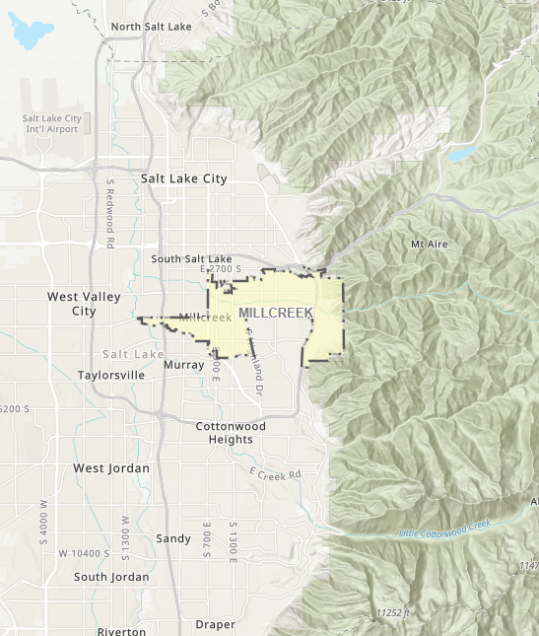

Figure 2 – Millcreek Waterways and Storm Drain System Maps
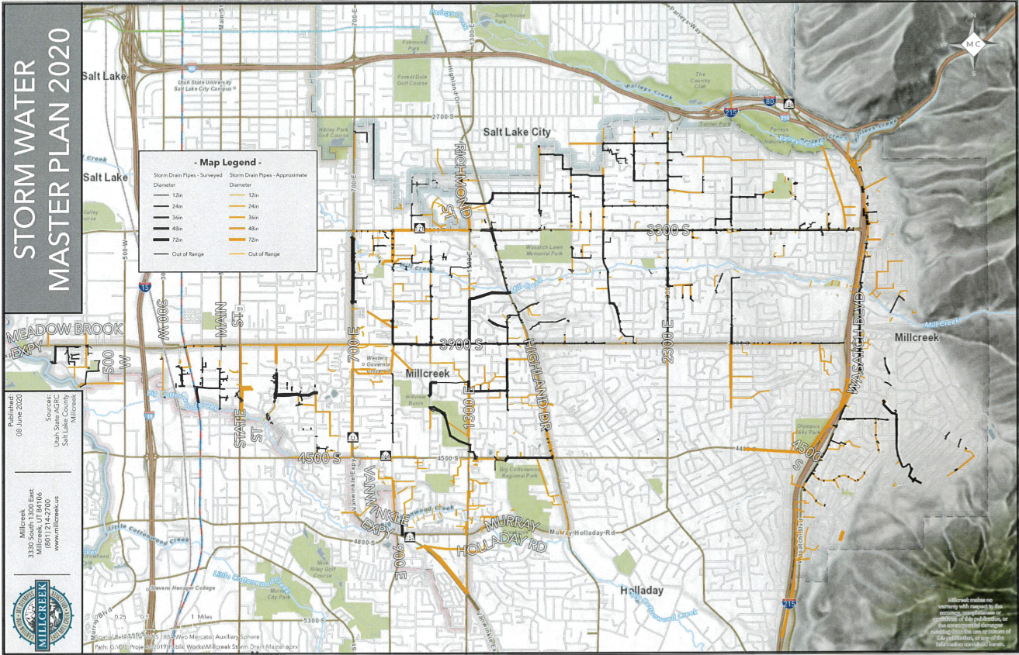
Figure 3 – Organization Flow Chart
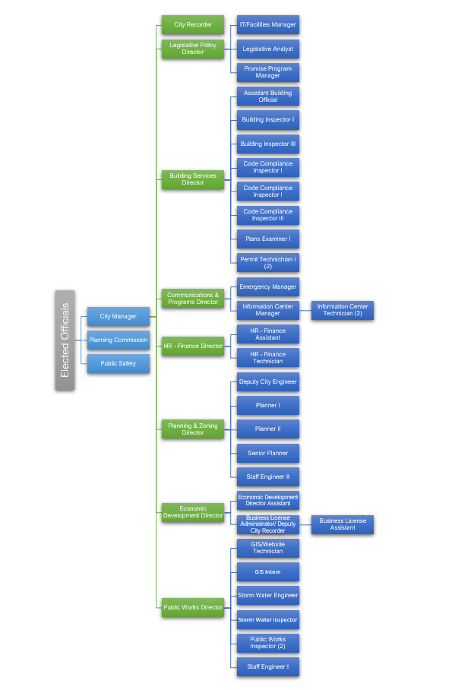

Purpose
This 2020-2025 SWMP identifies tasks for development and implementation through the current permit cycle (set to expire on February 25, 2025). This SWMP will be updated as required per the renewed permit. These tasks are designed to address the six minimum control measures (MCMs) for Phase II permittees and are listed below:

- Public Education and Outreach on Stormwater Impacts
- Public Involvement and Participation
- Illicit Discharge Detection and Elimination
- Construction Site Stormwater Runoff Control
- Long-term Stormwater Management in New Development and Redevelopment
- Pollution Prevention and Good Housekeeping for Municipal Operations

Other permit requirements that incorporate all these MCMs include record keeping and reporting.

SWMP REVIEW AND MODIFICATION
An annual review of this SWMP will be conducted in conjunction with the required Annual Stormwater Report; any changes or modifications will be submitted to the Utah Division of Water Quality (DWQ) in accordance with Part 4.5 of the permit. This review will include the following:
- A review of the status of program implementation and permit compliance.
- A review of any revision or change of BMPs during the year and an assessment of the effectiveness of such revision. The DWQ will be notified of any changes to the implementation of BMPs. This notification will include the rationale supporting the modification in accordance with Part 4.5.2 of the permit.
- An overall assessment of the goals and direction of the SWMP and effectiveness of BMPs.

2.4 STAFFING AND RESOURCE ALLOCATIONS
Management and oversight of the Stormwater Management Program is funded by Millcreek through municipal sales tax. Millcreek (Mayor and City Council) approved a stormwater utility fee ordinance on July 22, 2020 as a funding source for the program. The Stormwater Management Program has been programmed to include 4.0 full-time equivalent (FTEs). Other Millcreek employees may assist a portion of their time as needed to meet the permit requirements. Multiple Millcreek employees have also received Registered Stormwater Inspector (RSI) training to assist with the Construction Run-off Control program as needed. In addition, approximately 1.0 FTE’s are contracted from Salt Lake County Operations to provide stormwater maintenance services.
The Public Education and Outreach on Stormwater Impacts Program is conducted in coordination with the Salt Lake County Stormwater Coalition. In April 2018, Millcreek joined the Coalition to meet the public education and outreach requirements. This program is discussed in detail in Section 4.0 of this plan. This Coalition is funded by the Co-permittees, as well as the Utah Department of Transportation, Davis County, and the Salt Lake County Health Department. The Coalition is responsible for developing and distributing the educational materials.
The Public Involvement/Participation Program is mainly conducted by Millcreek. A Millcreek Engineering Stormwater Program webpage will be developed for public input about Millcreek’s SWMP, related stormwater documents, and a public comment/complaint link. A Leaf Bag Collection Program is being conducted by Wasatch Front. The effectiveness of other public involvement activities will be evaluated and implemented in the SWMP. Currently, the public can report illicit discharges and other code violations to Millcreek’s Report A Concern Link https://millcreek.us/FormCenter/Communications-9/Report-a-Concern-51. Other public involvement activities (e.g. public opinion polls) are coordinated with the Salt Lake County Stormwater Coalition.
The Illicit Discharge Detection and Elimination Program is conducted by Millcreek in coordination with the Salt Lake County Health Department. The Health Department responds to complaints regarding spills and illegal discharges and takes enforcement actions as necessary. This program includes a Dry Weather Screening Program, a stormwater system map (Figure 2) and illicit discharge enforcement coordination with the Salt Lake County Health Department.
The Household Hazardous Waste Program is funded by the Salt Lake County Health Department through the collection of a tipping fee assessed at landfill facilities.
The Construction Site Stormwater Runoff Control Program and the Long-term Stormwater Management Program are implemented by Millcreek Engineering, Planning & Development Review Services. This includes conducting SWPPP reviews of planned development, construction site inspections, permit enforcement, and long-term BMP plan reviews and inspections.
The Pollution Prevention and Good Housekeeping Program is implemented mainly by Salt Lake County Public Works Operations – Millcreek currently contracts Public Work services through County Public Works Operations. Millcreek will assist in the implementation of this program as required.
Recordkeeping and reporting tasks are primarily performed by Millcreek Engineering. All appropriate agencies will assist in the fiscal analysis.

2.5 PROGRAM SUMMARY
This SWMP has been developed to meet the requirements of the UPDES permit and consists of the six minimum control measures (see Part 2.2) established by EPA for Phase II municipal stormwater discharges. Implementation of these control measures are designed for the purpose of minimizing the discharge of stormwater pollutants to surface waters. Each control measure contains best management practices (BMPs) necessary for proper stormwater management. The BMPs contained herein include specific tasks to meet the objective of that control measure. This SWMP is intended to be a dynamic document with BMPs added and deleted as new management practices arise and other management practices are found to be less effective.
A brief description of each BMP program (beginning in Chapter 4 and continuing through Chapter 10) relating to the minimum control measures is provided below.
Chapter Four – Public Education and Outreach on Stormwater Impacts
This measure is intended to ensure greater public support for the stormwater program and greater compliance through education. An informed public can significantly contribute to the success of the program. In 1999, Salt Lake County implemented the use of a Focus Group to determine the most effective mechanism for educating the public on stormwater issues. Results of the Focus Group indicated that by educating school children (4th graders); the children are likely to take the information to their family.
In general, Millcreek emphasizes education in the SWMP because it is a cost-effective BMP and is proactive in trying to reduce stormwater pollutants rather, than reactive by treating the stormwater pollutants. The BMP programs in this chapter include:
- Resident’s Education Program
- Institutions, Industrial and Commercial Facilities Education Program
- Developer’s and Contractor Education Program
- MS4 owned or operated Facilities
- Salt Lake County Stormwater Coalition

Chapter Five – Public Involvement/Participation
This measure is intended to provide opportunities for the public to play an active role in both the development and implementation of the stormwater program. An active community is important to the success of a stormwater program. The BMPs in this chapter not only serve to involve the public in the stormwater program, but also function to educate the public on stormwater issues. The BMP programs in this chapter include:
- Public involvement
- Public participation

Chapter Six – Illicit Discharge Detection and Elimination
This measure is intended to minimize the illicit discharges into the storm drain system. Illicit discharges are discharges that are not composed entirely of stormwater (except as allowed by permit, Part 1.2.2.2), as storm drain systems are not designed to accept, process or discharge such non-stormwater wastewaters. Minimizing these discharges can help to prevent high levels of pollutants from entering receiving waters. The BMP programs in this chapter include:
- Illicit Discharge Ordinance
- Mapping
- Illicit Detection and Elimination (IDDE) Plan (in development and under review)
- Program Evaluation and Assessment
- IDDE Training

Chapter Seven – Construction Site Stormwater Runoff Control
This measure is intended to minimize polluted stormwater runoff from construction activities. Construction activities can contribute significant levels of sediment to stormwater runoff if erosion and sediment controls are not implemented. The BMP programs in this chapter include:
- Construction Site Runoff Ordinance
- Pre-Construction Reviews
- Inspection and Enforcement
- Construction Site Runoff Training
- Records Keeping

Chapter Eight – Long-term Stormwater Management in New Development and Redevelopment
This measure is intended to minimize the impact to stormwater quality caused by development and redevelopment. The increase in impervious areas caused by development can result in an increase in the type and quantity of pollutants in stormwater runoff. Prior planning and design to minimize pollutants in runoff from these areas is an important component to stormwater quality management. The BMP programs in this chapter include:
- Long-term Stormwater Management Ordinance
- Long-term Stormwater BMPs
- Site Plan Review Procedures
- Inspections and Enforcement
- Long-term Stormwater Management Training
- Long-term Stormwater BMP Inventory

Chapter Nine – Pollution Prevention and Good Housekeeping for Municipal Operations
This measure is intended to ensure a reduction in the amount and type of stormwater pollutants by establishing routine activities in the operation and maintenance of municipal operations that address stormwater runoff. Setting specific guidelines and routine activities that have the potential to impact stormwater quality is an important component to stormwater quality management. The BMP programs in this chapter include:
  - Municipal Maintenance – Storm Drain system maintenance, street sweeping, and snowplow services are currently provided by Salt Lake County Operations
  - Facility Inventory - Currently, Millcreek leases one building for its City Hall Building.
  - Millcreek owned and operated Parks: Sunnyvale, Canyon Rim, Scotts Ave, & Fortuna
  - Millcreek Construction Projects
  - Employee Training

Chapter Ten – Recordkeeping, Reporting, and Responsibility Agreements
This chapter provides a summary of the SWMP effectiveness evaluation and reporting that is required by the UPDES permit. The permit also requires reporting of all stormwater activities conducted under this SWMP and routine evaluation of the effectiveness of the SWMP to make modifications as necessary. The BMP programs in this chapter include:
- Record Keeping
- Reporting
- Responsibility Agreement

SPECIAL CONDITIONS
The UPDES permit requires the SWMP address potential impacts to impaired waterbodies, threatened and endangered species, and historic properties with regards to the discharge of stormwater. This section provides a discussion of these issues.

Discharges to impaired waters
In accordance with the Utah 2016 Integrated Report (Department of Environmental Quality,2016), there are currently four impaired waterbodies in Millcreek. Summarized below in Table 1 is information on the Total Maximum Daily Load (TMDL) studies for these water bodies.
Table 1 - Impaired Waterbodies in Millcreek
Watershed Management Unit | Watershed Management Name | Location of Impairment | Beneficial Use¹ | Pollutant(s) | TMDL Status/  Priority
Jordan River/ Utah Lake | Big Cottonwood Creek | From the Jordan River to the Big Cottonwood Water Treatment Plant | 3A  2B | Temperature,  Benthic Invertebrate  E. Coli | TMDL  Required
Jordan River/ Utah Lake | Mill Creek | From I-15 to USFS Boundary | 2B  3A  4 | E. Coli  Benthic Invertebrate | TMDL  Required
Jordan River/ Utah Lake | Parleys Canyon Creek | From 1300 East to Mountain Dell Reservoir | 1C, 2B  3A | E. Coli  Benthic Invertebrate, Dissolved Oxygen | TMDL  Required
Jordan River/ Utah Lake | Jordan River | City south border to north border | 2B, 4 | TDS,  E.Coli,  Benthic Invertebrate | TMDL Required
¹ 1C – Domestic Water Supply
2B – Secondary Contact Recreation
3A – Cold Water Species of Game Fish
3B – Warm Water Species of Game Fish
4 - Agricultural

Millcreek currently discharges stormwater to Mill Creek, Parley’s Creek, Big Cottonwood Creek, and the Jordan River. Millcreek has implemented BMPs with the intent to minimize the discharge of stormwater pollutants. Millcreek will continue to implement BMPs and will evaluate potential impacts to impaired waterbodies. The status of the TMDLs for these waterbodies is as follows:

- Big Cottonwood Creek – TMDL required, Temperature, E.Coli, Benthic Invertebrate
- Mill Creek – TMDL required, E.Coli, Benthic Invertebrate Assessment
- Parley’s Canyon Creek – TMDL required; E.Coli, Benthic Invertebrate, Dissolved Oxygen
- Jordan River – TMDL Required, Total Dissolved Solids, E.Coli, Benthic Invertebrate

Parley’s Creek goes to the 1300 South storm drain pipe that discharges to the Jordan River. Mill Creek and Big Cottonwood Creek go directly to the Jordan River. The Jordan River has an approved TMDL for E.Coli,TDS and Benthic Invertebrate.

3.2 NITROGEN AND PHOSPHOROUS REDUCTION

Millcreek’s SWMP will address the reduction of water quality impacts associated with nitrogen and phosphorous in discharges from the MS4.

Objective: Reduce degrading water quality impacts due to Nitrogen and Phosphorous run-off point sources into Millcreek’s MS4 system and receiving waters. Millcreek’s largest potential contribution of nitrogen and phosphorous to MS4 receiving waters has been identified as residential and commercial fertilizing and landscape practices.

Permit Requirement: Part 3.2 and 4.2.1

Description of Tasks: Participate with the Salt Lake County Coalition and other Agencies to evaluate, identify, target, and provide outreach to sources generating these pollutants. Incorporate this task into Millcreek’s education and outreach strategies (newsletter, billing inserts, social media, and City events). Targeted newsletter articles, mailings and social media campaigns have been implemented in Spring and early Summer to target residential and commercial nitrogen and phosphorus from fertilizing and landscaping practices.

3.3 POLLUTANTS OF CONCERN

Millcreek’s SWMP will address all pollutants of concern and best practices on how to manage these pollutants.

Objective: Reduce degrading water quality impacts due to pollutants of concern sources into Millcreek’s MS4 system and receiving waters.

Permit Requirement: Part 3.1

Description of Tasks: Participate with the Salt Lake County Coalition and other Agencies to evaluate, identify, target, and provide outreach to sources generating these pollutants. Incorporate this task into Millcreek’s education and outreach strategies (newsletter, billing inserts, social media, and City events).

Polluants of Concern have been identified as; E.Coli, Nitrogen & Phosphorus, Sediment, Total Dissolved Solids and Trash.

Measures to control Pollutants of Concern:
- Good Housekeeping (targeted sweeping and vactoring in areas of concern; Olympus Cove, Scott Avenue Park)
- Public Education (newsletter mailings, social media campaigns, website education regarding pollutants of concern)
- Public Outreach (City events, Salt Lake County Coalition events)
- Retro fit plan (in progress) to add BMPs in targeted locations for pollutants of concern

3.4 E.COLI RESPONSE PLAN

Millcreek’s SWMP will address the Jordan River E.Coli TMDL in the following ways:

- Public Education and Outreach
- Inventory of E.Coli sources
- MS4 Owned and Operated Facilities
- LID Controls
- E.Coli ranking in retrofit plan

Millcreek will identify and prioritize E.coli reduction activities to address the areas and sources identified in high priority area and facilities SOPs. As part of this process Millcreek will identify the following structural and non-structural BMPs for implementation.

Prioritization Considerations:

- Site proximity to Water of State
- Source of E.Coli
- Magnitude of E.Coli loading
- Practical and economic feasibility of implementation of structural and/or non-structural BMPs
- Location factors
- Cost

BMPs to be used in these prioritized areas:

- Non-structural
  - Increased sweeping and vactoring in priority areas
  - Clean-up pet and waterfowl areas prior to storm events
  - Keep pet waste bags stocked
  - Clean out pet waste receptacles regularly
  - Partner programs to work with unhoused populations
  - Regularly educate target audiences
  - Riparian set-backs from waters of the state
- Structural
  - Waste containment areas
  - Identification of illicit cross-connections
  - Updates to MS4 infrastructure
  - LID Controls

PUBLIC EDUCATION AND OUTREACH on Stormwater Impacts
The Public Education and Outreach on Stormwater Impacts Program is intended to increase public awareness of impacts associated with pollutants in stormwater runoff and illicit discharges. Millcreek in cooperation with the Salt Lake County Stormwater Coalition, implements an education program that includes a multi-media approach. With this approach, Millcreek reaches a wider audience which serves to make the stormwater management program more successful. This approach has included TV and movie commercials, educational brochures and flyers, a Water Fair and more.
The BMPs in this program will target four audiences in accordance with Part 4.2.1. of the permit. These audiences are: 1) residents, 2) institutions, industrial and commercial facilities, and 3) developers and contractors, and 4) MS4 owned or operated facilities The information provided to these audiences includes potential impacts of stormwater on receiving waters and methods for minimizing these impacts. Focus will be on the reduction of phosphorous and nitrogen in outreach programs.

4.1 summary of tasks
This program integrates other facets of the SWMP to provide up-to-date information, including the Illicit Discharge Detection and Elimination, the Construction Site Stormwater Runoff Control, Long-term Stormwater Management and Good Housekeeping Programs. The following BMPs describe implementation and assessment tasks to be completed and responsible parties. Progress towards the measurable goals will be documented in the Annual Stormwater Report.

RESIDENTS EDUCATION PROGRAM
Objective: Reduce stormwater pollutants to receiving waters by increased public awareness of problems and solutions.
Permit Requirement: Part 4.2.1, 4.2.1.1.,4.2.1.2.,4.2.1.6. & 4.2.1.7 – Public Education & Outreach on Stormwater Impacts
Part 4.2.3. – Illicit Discharges Detection & Elimination
Description of Tasks: Provide residents with educational materials, demonstrations, and outreach activities regarding the impact of daily activities on stormwater quality. Information will target specific pollutants impacting the beneficial uses of the receiving waters and ways to reduce or eliminate these pollutants. Topics will include maintenance, effects of outdoor and household activities, including vehicle maintenance on stormwater quality, benefits of on-site infiltration, and proper management of pet waste.
Provide evidence that defined goals and being achieved and document rationale for selecting BMPs used in public education and outreach program,
Water Quality Fair: With cooperation from the Stormwater Coalition and other interested and willing agencies, the water quality fair is held annually. The venue is currently at the Hogle Zoo in Salt Lake City. The fair consists of a series of booths and informational demonstrations presented by individual agencies; topics include stormwater pollution and other water related issues. This fair is held for fourth grade students and coincides with the Water Cycle in the current school curriculum. Students are bused to the zoo and spend a morning visiting the booths. Stormwater educational materials and give-aways are distributed. The intent is not only to provide stormwater information to the students, but for this information to be received by the students’ families as well; potentially reaching a larger audience.
Media Campaign: The Salt Lake County Stormwater Coalition conducts a mass media campaign to further educate residents about stormwater pollution and prevention. The Coalition has developed several commercials addressing stormwater issues over the years and continues to produce updated versions. The Coalition partners with top rated TV stations in the Salt Lake market, reaching a large portion of residents. These campaigns typically run for a two- to three-week period and are also broadcast in movie theaters. Additional campaigns will be conducted as opportunities arise.
Educational Materials: Distribution of educational materials is designed to inform communities of the impacts of stormwater discharges on local waterbodies and ways in which people can reduce this impact. These materials include educational materials and give-aways such as tabloids, activity books, pencils, note pads, posters, etc. Many of the educational materials are developed through the Salt Lake County Stormwater Coalition (see Section 4.1.6). The materials are primarily distributed to 4th graders in the public and private schools within Salt Lake County and ties in with the Water Cycle curriculum. It is optimal to distribute the materials once a year when students can practice what they learn and more easily visualize stormwater runoff (i.e., spring and fall). The number and type of materials that are distributed will be documented. These materials will be updated as necessary. Other Millcreek events where stormwater quality information will be provided to Millcreek residents include the Venture Outdoor Series (not held 2020 due to COVID-19 restrictions).held during the summer and an annual resident rain harvesting/barrel event.
Informational Brochures will be made available covering the following topics:
- Erosion Control
- Fresh Concrete and Mortar Application
- Household and Vehicle Maintenance
- Landscaping, Gardening and Yard Maintenance
- Paint and Household Hazardous Waste
- Pet Waste and Water Quality
- E.Coli and other Pollutants of Concern

Internet and Social Media: The Salt Lake County Stormwater Coalition has maintained a website http://www.stormwatercoalition.org/ for several years. This website not only provides stormwater information and training, but provides links to other sites for information, as well as member sites for more local information. The Salt Lake County Stormwater Coalition updates this website as necessary. In addition, the Coalition has broadened its use of social media to include Facebook and Twitter, with the intent to reach a younger audience with the information.
Millcreek also utilizes social media, weekly and monthly newsletters to educate residents about water quality related issues. Millcreek will continue to evaluate ways reach a larger audience.

INSTITUTIONS, INDUSTRIAL AND COMMERCIAL FACILITIES EDUCATION PROGRAM
Objective: Reduce the discharge of stormwater pollutants to receiving waters by providing information to businesses regarding illicit discharges and the potential impacts.

Permit Requirement: Part 4.2.1.3. – Public Education & Outreach on Stormwater Impacts
Part 4.2.3. – Illicit Discharges Detection & Elimination
Description of Task: Inform businesses, industries, and commercial entities about the impacts of stormwater discharges on receiving waters and steps that can be taken to reduce pollutants in stormwater runoff through outreach activities and/or educational materials. Provide information about the storm drain system and the consequences of illegal discharges and improper disposal of waste.

DEVELOPERS AND CONTRACTORS EDUCATION PROGRAM
Objective: Reduce pollutants to receiving waters by providing information to the construction industry with regards to construction activities and impacts to stormwater quality.
Permit Requirement: Parts 4.2.1.,4.2.1.1., 4.2.1.4. – Public Education & Outreach on Stormwater Impacts
Part 4.2.4. – Construction Site Stormwater Runoff Control
Part 4.2.5. - Long-term Stormwater Management in New Development & Redevelopment
Description of Task: Provide engineers, construction contractors, developers, development review staff, and land use planners with educational materials regarding stormwater regulations, including the requirement to develop Stormwater Pollution Prevention Plans (SWPPP) at construction sites one acre or greater in size or less than acre if it is part of a common plan of development. Information regarding stormwater regulations and Millcreek’s stormwater quality ordinance Title 17, Chapter 17.22., including the Land Disturbance Permit will be provided at a pre-construction conference. The requirements for developing a SWPPP and short-term and long-term Best Management Practices (BMPs) will also be provided. The targeted and specific pollutants impacting receiving waters will be addressed in the SWPPP.

MS4 OWNED OR OPERATED FACILITIES
Objective: Reduce pollutants to receiving water by providing information to MS4 engineers, development and plan review staff, Operations and facility employees, and land use planners about LID practices impacting water quality from MS4 owned or operated facilities.
Permit Requirement: Parts 4.2.1, 4.2.1.5.

Description of Task: Provide employees of MS4 owned and operated facilities with training that provide information about the impacts of stormwater quality related to activities conducted by City staff.

Evaluate Effectiveness of Public Education and Outreach Programs
Objective: Improve effectiveness and reach of public outreach programs.

Permit Requirement: Parts 4.2.1.6. & 4.2.1.7.

Description of Tasks: Evaluate effectiveness of each bmp by tracking and documenting outreach activities and evaluating overall results of program to determine if defined goals of program were achieved.

SALT LAKE COUNTY STORMWATER COALITION
Objective: Increase public and professional awareness of stormwater quality concerns with consistent and combined marketing methods.
Permit Requirement: Part 4.2.1. – Public Education and Outreach on Stormwater Impacts
Description of Tasks: Coordinate and participate in the Salt Lake County Stormwater Coalition to provide education and training for professionals and municipal employees with regards to stormwater quality. This Coalition is open to the public and consists of co-permittee representatives whose purpose is reducing the load of pollutants entering the storm drains and receiving waterbodies and enforcing the appropriate regulations. The Coalition meets monthly to coordinate new educational materials/programs, discuss stormwater program development and inform members of new regulations and conferences.
A budget for the educational program is established each year with the assistance of a Consultant. Through inter-local agreements and voluntary contributions, the program is funded by participants. The types of media and timing for distribution are discussed so that the public can be targeted during the spring and the fall. Other factors that are taken into consideration in choosing the types of media are the average number of times that a person will see the advertisement. Examples of the types of educational materials that are developed through the Coalition are:
- Television commercials | - Posters | - Public surveys
- Theater commercials | - Leave behind items | - Brochures
- Tabloids  - Billboards  - Bus Advertisements | - Activity books

The Coalition documents the number and type of all materials that are distributed. Currently, the Coalition participants are listed below:
- Salt Lake City
- Salt Lake County Health Department
- UDOT, Region 2
- Jordan Valley Municipalities Phase II Co-permittees (14)

Goals and Assessment
The table below represents measurable goals for this program to be implemented and assessed during the permit term in coordination with the Salt Lake County Stormwater Coalition. The purpose of measurable goals is to gauge permit compliance and program effectiveness following the schedule identified.
Table 2 Public Education & Outreach Program Goals and Assessment
Year | Task | Goal/Frequency | Assessment | Responsibility
2020-2025 for all | Residential Education Water Quality Fair | - Continue annual water quality fair for 4th grade students | Document number of students attending & information distributed | MS4 Program Manager/SL County Stormwater Coalition
 | Residential Education Media Campaign | - Continue media campaign/2-3 weeks per year | Document # of airings & # of people reached | MS4 Program Manager/SL County Stormwater Coalition
 | Residential Education Materials | - Develop and Distribute educational materials via Millcreek newsletter, billings and social media outlets and SWUF billings for all | Document types & quantity of materials distributed | MS4 Program Manager/SL County Stormwater Coalition
 | Residential Education Brochures | - Update and post on website; | Document types & quantity of materials distributed | MS4 Program Manager/SL County Stormwater Coalition
 | Institutions, Industries & Commercial Brochures | - Develop and distribute educational materials. Add as part of business license approval. | Document types & quantity of materials distributed | MS4 Program Manager/SL County Stormwater Coalition
 | Developers & Contactors Information | - Develop and distribute educational materials. Add to pre-con meetings | Document types & quantity of materials distributed | MS4 Program Manager/SL County Stormwater Coalition
 | MS4 and City staff | - Effectively train city staff on Water quality | Document trainings | MS4 Program Lead and stormwater staff
 | Salt Lake County Coalition | - Continue participation in the Coalition/monthly  - Represent Millcreek at USWAC & JRWC meetings/monthly & quarterly as needed. | Document meetings, & agendas | MS4 Program Manager/SL County Stormwater Coalition
 | Selected bmps | - Evaluate effectiveness | Document bmp effectiveness | MS4 Program Manager
 | BMP rationale | - Select most effective BMPs in reaching wider audiences | Documentation process | MS4 Program Manager

PUBLIC INVOLVEMENT/PARTICIPATION
The Public Involvement/Participation Program section of the SWMP addresses the importance of public involvement with respect to protection of stormwater. Community participation provides for broader public support, shorter implementation schedules, a broader base of expertise and the development of important relationships with other community and government programs. The BMPs described in this section include opportunities for the public to play an active role in the City’s stormwater program.

summary of tasks
This program complements the Public Education and Outreach Program, providing for public input into the stormwater program as well as some active community programs. The following BMPs describe implementation tasks and assessment tasks to be completed by Millcreek for the Public Education Involvement/Participation Program. Progress towards the measurable goals will be documented in the Annual Report.

PUBLIC INVOLVEMENT
Objective: Provide opportunities for public involvement in the development and implementation of the SWMP, as well as stormwater related ordinances.
Permit Requirement: Part 4.2.2.1., 4.2.2.2., 4.2.2.3. & 4.2.2.4. – Public Involvement/ Participation
Description of Task: Provide opportunity for public to review and comment on the SWMP and other regulatory mechanisms for SWMP implementation. The Millcreek SWMP is posted on Millcreek’s website and is available for public comment. Comments will be reviewed and incorporated as appropriate.

PUBLIC PARTICIPATION
Objective: Provide opportunities for public participation with regards to reducing the discharge of pollutants to stormwater runoff.
Permit Requirement: N/A
Description of Tasks: Provide opportunity for public to participate in a stormwater activity and provide education with regards to related programs. Millcreek will evaluate the best ways to involve the public and implement this control measure.

PUBLIC SURVEY
Objective: Evaluate the effectiveness of the public education and outreach program through use of a public survey. The survey will be used to evaluate the recognition of the stormwater message and the impact the information has on residential, commercial, and industrial habits with regards to stormwater.
Permit Requirement: Part 4.2.1.7. – Public Education and Outreach on Stormwater Impacts
Description of Task: The Salt Lake County Stormwater Coalition conducted public surveys associated with stormwater issues in 1993, 1998, 2003 and 2010 and most recently in 2017. The purpose of these surveys is to determine what type of information needs to be conveyed to the public, what behaviors people have that may impact stormwater quality, and their knowledge of stormwater issues. The survey information is used to evaluate and modify the stormwater education program accordingly. The Coalition will continue to conduct these surveys once during a permit term.
Storm Drain Inlet Identification Program: A program utilizing community groups to glue markers on storm drain inlets serves to discourage illicit dumping and littering. Typical groups that participate in the Storm Drain Inlet Identification program are Scouting organizations and school groups. This program is under further investigation to evaluate the placement of additional markers. Many new inlet boxes will have no dumping engravings.
Used Oil Program: This program is administered by the Utah Department of Environmental Quality in conjunction with the Salt Lake County Health Department. This program helps to educate the public regarding the requirements for disposing of used oil in the other educational materials (tabloid, activity book, etc.)
Leaf Bag Collection Program: Leaf bags are available for residents of Millcreek for the purpose of composting leaves during the fall. The intent is to minimize the amount of leaves that enter the storm drain system. The public is instructed to take filled bags to a central location in a park where they are transported to the Solid Waste Management Facility and composted. The overall green waste (tonnage) including leaf bags is documented within each jurisdiction by Wasatch Front Recycling.
Rain Barrel/Harvesting Events: Millcreek hosts an annual rain harvesting event in in conjunction with the Utah Rivers Council where residents can purchase a rain barrel at a discounted price and learn more about rain harvesting techniques.
Venture Out Summer Events: Millcreek hosts a booth about City activities and participates in a water quality quiz with prizes. This is also part of Millcreek’s public education and outreach program.

Goals and Assessment
The table below represents measurable goals for this BMP to be implemented and assessed during the permit term. The purpose of measurable goals is to gauge permit compliance and program effectiveness following the schedule identified.
Table 3 Public Involvement/Participation Program Goals and Assessment
Year | Task | Goal/Frequency | Assessment | Responsibility
2020-2025 for all | Public Review of SWMP & Ordinance | - Post draft & final SWMP, stormwater ordinances, documents on website for permit term | Document, respond & incorporate comments into SMWP & ordinance as appropriate | MS4 Program Manager
 | Storm Drain Inlet Identification Program | - Evaluate need for additional markers. | Document number of groups & catch basins identified | MS4 Program Manager
 | Used Oil Program | - Promote Used Oil Program in educational materials on an on-going basis | Document materials that include the Used Oil Program information | MS4 Program Manager
 | Leaf Bag Collection Program | - Make leaf bags available to unincorporated County residents annually | Document number of leaf bags distributed & collected | Wasatch Front  Recycling
 | Public Survey | - Conduct survey to evaluate effectiveness of education program once per permit term | Document results & modify program accordingly | MS4 Program Manager/SL County Stormwater Coalition
 | Rain Harvesting Event | - Educate public about benefits/Annual | Document results & modify program accordingly | MS4 Program Manager/SL County Stormwater Coalition
 | Venture Out | - Educate public/Annual (not held in 2020 due to COVID19 restrictions) | Document results & modify program accordingly | MS4 Program Manager

6.0 ILLICIT DISCHARGE DETECTION AND ELIMINATION
The Illicit Discharge Detection and Elimination (IDDE) Program addresses non-stormwater flows that are discharged to receiving waters via stormwater conveyance systems. This program includes implementation of BMPs to assist in the identification of illicit discharges and removal of these discharges. This program will also focus on prevention of new illicit discharges to the stormwater system by means of education, regulations, and through spill prevention and response. This program will be coordinated with other Agencies, including by not limited to, Millcreek Code Enforcement, Salt Lake County Health Department, Environmental Task Force, and Salt Lake County Stormwater Coalition. The State DWQ and EPA will also be included if necessary or required.

6.1 summary of tasks
This program will also be integrated with the Public Education and Outreach and the Public Involvement/Participation Programs to promote awareness of the importance of protecting the stormwater system from illicit discharges and the resultant impact to receiving waters. Millcreek will coordinate and participate with other agencies for the purpose of enforcing against and reducing illicit discharges. Millcreek will also provide support to federal, state, and other local entities in the efficient control of contaminants as required under appropriate regulations, such as the Stormwater Permit Program and the Class V Well Inventory Program. Agencies commonly coordinated with include:
- Fire Department | - Utah Division of Water Quality
- Landfills | - Recycling Information Office
- Salt Lake County Health Department | - All municipalities in Salt Lake County
- Solid Waste Management Facility | - Wastewater Pretreatment Program

The following BMPs describe implementation tasks and assessment tasks to be completed by Millcreek for the IDDE Program. Progress towards the measurable goals will be documented in the Annual Stormwater Report.

ILLICIT DISCHARGE DETECTION AND ELIMINATION PLAN ORDINANCE

MAPPING
Objective: Maintain a current map of the storm drain system to assist response agencies during spill events and conduct outfall screening. This map will include pipes, inlets, outfalls and other related information
Permit Requirement: Part 4.2.3.1. – Illicit Discharge Detection and Elimination
Description of Tasks: Update maps to assist in the IDDE and monitoring programs.
Storm Drain System Map: Update and maintain current Millcreek system map as required to determine the source and extent of dry weather flows and the particular water bodies these flows may be impacting. The map will include information specific to each outfall, including size, type and receiving waters. The map will include the names and location of all receiving water bodies.
Catchment Basin Map: Update the facility map to include catchment areas. This map will be of use for maintenance and enforcement purposes. In addition, this information is important potential sources of illicit discharges.
Land Use Map: The land use map is important for use in tracing dry weather flows.
Objective: Effectively prohibit illicit and illegal discharge through an ordinance.
Permit Requirement: Part 4.2.3.2. – Illicit Discharge Detection and Elimination
Description of Task: Millcreek has adopted an ordinance designed to minimize stormwater pollution and establishes enforcement procedures (Title 17, Chapter 17.22 Stormwater Quality). Illicit discharges are defined as any discharge to the storm drain system that is not composed entirely of stormwater, with the exceptions as listed in Part 1.2.2.2. of the permit. Examples of illicit discharges include sanitary wastewater, improper disposal of waste oil, paint, household toxics and spills from roadway accidents. This ordinance provides for the legal authority to enter and inspect a facility to ensure compliance. Other illicit discharge regulations adopted by the Salt Lake County Health Department in coordination with Millcreek include: Health Regulation #13 Wastewater Disposal prohibits such acts as placing or conducting “any sewage or wastewater into any storm drain system, street, alley…”. Health Regulation #14 Watershed Regulation prohibits several acts, all with the intent to protect the watershed and prevent watershed pollution. The County Health Department also utilizes the Clean Water Act to prevent pollution of the County’s waterways. The County Health Department has adopted the Civil Penalty Determination from the Utah Administrative Code (UAC R317-1.9) that provides guidance when assessing penalties. This consists of escalating penalties depending upon the severity of the violation as well as the history of the non-compliance.
6.1.3 ILLICIT DISCHARGE DETECTION AND ELIMINATION PLAN (IDDE)
Objective: Develop and implement a plan designed to reduce illicit discharges to Millcreek’s storm drain system. This plan will encompass many of the components in this SWMP (e.g. ordinance, public education, agency cooperation), as well as investigation and enforcement procedures.
Permit Requirement: Part 4.2.3. – Illicit Discharge Detection and Elimination
Part 4.2.1 – Public Education and Outreach on Stormwater Impacts
Part 4.2.2 – Public Involvement/Participation
Description of Tasks: Develop and implement an IDDE plan that includes adequate ordinances that provide for Millcreek access and enforcement activities. Storm drain system mapping, dry weather screening, agency coordination and public education are all components of an effective IDDE plan. SOPs for Illicit Discharge Detection and Elimination are housed in the “Storm Water SOP Manual”.
Dry Weather Screening: Dry weather screening consists of annually inspecting 20% of the outfalls (greater than 12” in diameter) that discharge to Mill Creek, Big Cottonwood Creek, Parleys Creek, and the Jordan River during the 5 year permit term. The Dry Weather Screening Program provides a framework for field screening the outfalls to identify suspected outfalls as a basis for initiating more detailed drainage area investigations and enforcement procedures. In addition, this program requires annual training for municipal employees. This plan is developed and implemented by Millcreek.
Priority Area Screening: Develop and implement written procedures for locating and listing the priority areas based on the criteria noted below. The basis for priority area selection will be documented and updated to reflect a change in the priority areas. Field assessment of at least 20% of these priority area outfalls will be conducted each year. SOP for assessment selection and Inspection house in “Storm Water SOP Manual”.
- Areas with older infrastructure
- Industrial, commercial, or mixed-use areas
- Areas with a history of past illicit discharges and/or illegal dumping.
- Areas with onsite sewage disposal systems
- Areas with older sewer lines or with a history of sewer overflows or cross-connections
- Areas upstream of sensitive waterbodies
- Other areas Millcreek determines to be likely to have illicit discharges

Tracing Illicit Discharge Source: Implement screening investigations to trace the source of all illicit discharges. Refer to Millcreek’s Dry Weather Screening Plan (Appendix C – pg. 44).
Characterizing the Illicit Discharge: Implement procedures to characterize all illicit discharges when found. These procedures will include instructions for containment. Documentation will include:
- Date of report of illicit discharge
- Date of investigation initiation
- Date discharge was observed
- Location and description of discharge
- Method of discovery
- Date of removal, repair, or enforcement action
- Date and method of removal verification
- Decision process for analytical monitoring
Eliminating Illicit Discharge: Implement procedures for ceasing the illicit discharge to the maximum extent possible. It is anticipated that in some cases the illicit discharge is a one-time occurrence or may be determined to be an allowable non-stormwater discharge. Immediate cessation of an illicit discharge is required. Procedures will include the following:
- Notification of appropriate authorities
- Notification of the property owner
- Technical assistance for removing the source of the discharge
- Follow-up inspections
- Enforcement and legal actions as appropriate
IDDE Education: Millcreek will develop and implement an IDDE education program identified in Section 4.0 of this SWMP.
Household Hazardous Waste Program: Millcreek will promote the Household Hazardous Waste Program administered by the Health Department and the Salt Lake Valley Solid Waste Management Facility. This program provides information to the public regarding proper disposal of household hazardous wastes.
Public Reporting: In association with the public education program (Section 4.0), Millcreek will provide information on public reporting of spills or other illicit discharges. To report a spill or illicit discharge, call Millcreek City Hall 801-214-2700 or click REPORT A CONCERN on Millcreek’s website. The Salt Lake County Health Department can be contacted at (385) 468-3862 during normal business hours and (801)-580-6681 for the 24-hour hotline for reporting of spills and illicit discharges. Calls can also be made to the Utah Department of Environmental Quality, to EPA or to 911 pending on the severity and impact of the spill. This information will also be posted on Millcreek’s website. Procedures for formal complaints are in place; Millcreek will work in conjunction with the Health Department to investigate the source of the pollution through a Memorandum of Understanding. Investigations and enforcement measures, including any fee penalties will be documented by Millcreek.
Millcreek has written procedures for responding to public reports of spills or illegal dumping, including a flow chart that shows actions to be taken for responding to public complaints, the various responsible agencies and personnel who will be involved in a response. This chart will be maintained in the SWMP (Appendix C – pg. 44) and will be updated as necessary.
Required permit notification: Millcreek will notify DWQ Director when UPDES permits are required for industrial and dewatering activities.

6.1.4 PROGRAM EVALUATION AND ASSESSMENT
Objective: Evaluate the program to determine effectiveness and any necessary modifications to minimize illicit discharges.
Permit Requirement: Part 4.2.3. – Illicit Discharge Detection and Elimination
Description of Task: Millcreek maintains stormwater program documents on a computer network. Millcreek maintains a GIS database for mapping and tracking the number and type of spills or illicit discharges identified and inspections conducted.

ILLICIT DISCHARGE DETECTION AND ELIMINATION TRAINING
Objective: Provide employee training to minimize illicit discharges.
Permit Requirement: Part 4.2.3. – Illicit Discharge Detection and Elimination
Description of Task: Millcreek will provide annual employee training (including field workers) with regards to the IDDE program. Train new employees within 60 days of hire date.
The table below represents measurable goals for this BMP to be implemented and assessed during the permit term. The purpose of measurable goals is to gauge permit compliance and program effectiveness following the schedule identified.
  - GOALS AND ASSESSMENT

The table below represents measurable goals for this BMP to be implemented and assessed during the permit term. The purpose of measurable goals is to gauge permit compliance and program effectiveness following the schedule identified.
Table 4 Illicit Discharge Detection & Elimination Program Goals and Assessment
Year | Task | Goal/Frequency | Assessment | Responsibility
2020-2025 for all | Ordinance | - Implement Chapter 17.22 on an on-going basis | Document activities conducted | MS4 Program Manager/Millcreek Engineering/Code Enforcement
 | Storm Drain System Maps | - Maintain storm drain system map by adding outfalls, pipe & BMPs as installed or discovered  - Update catchment map  - Update Land Use Map for Millcreek. | Update storm drain system map/ document  Update catchment map/ document  Update land use map/ document | Millcreek Engineering/GIS Specialist
 | IDDE Plan/  Dry Weather Screening | - Develop plan  - Screen all Millcreek outfalls at least once during the 5 yr. permit term/ 20% each year | Document process  Document findings of screening program, number of outfalls visited | MS4 Program Manager
 | Priority Areas | - Identify priority areas  - Inspect annually at a minimum | Document procedure  Conduct screening | MS4 Program Manager
 | Trace Illicit Discharge Sources | - Development and implementation of screening investigations to trace the source of an illicit discharge | Document investigation efforts | MS4 Program Manager
 | Characterize Illicit Discharges | - Development and implementation of procedures to characterize illicit discharges identified | Document investigation efforts | MS4 Program Manager
 | Eliminate Illicit Discharges | - Development and implementation of procedures as necessary for ceasing the illicit discharge when appropriate | Document investigation efforts | MS4 Program Manager
 | Public Education | - Develop Education program regarding illicit discharges, household hazardous wastes | Document materials distributed & recipients | MS4 Program Manager
 | Public Reporting | - Develop and implement program for receiving and responding to public information  - Implement flow chart for response to public reports | Document materials distributed & recipients  Document development & implementation chart | MS4 Program Manager
 | Database | - Maintain database for program evaluation & assessment | Maintain tracking database & evaluate program | MS4 Program Manager
 | Employee Training | - Provide annual employee training with regards to the IDDE program | Document training dates and attendees | MS4 Program Manager

7.0 CONSTRUCTION SITE STORMWATER RUNOFF CONTROL PROGRAM
The Construction Site Stormwater Runoff Control Program section of the SWMP addresses water quality concerns for construction sites greater than or equal to one acre, including projects less than one acre that are part of a larger common plan of development. Polluted stormwater runoff from construction sites often flows to storm drains and into receiving waters. This runoff can contribute more sediment to receiving waters than would otherwise naturally infiltrate into the ground, and can cause physical, chemical, and biological harm to receiving waters. The BMPs described in this section of the SWMP includes a construction site program designed to reduce pollutants in stormwater runoff from construction site activities.

summary of tasks
This program is integrated with the Public Education and Outreach Program and the Long-term Stormwater Management Program to provide stormwater information and permit compliance information to the public, contractors, and developers. The BMPs described herein include implementation tasks and assessment tasks to be completed by Millcreek for the Construction Site Stormwater Runoff Control Program. Progress towards the measurable goals will be documented in the Annual Report.

7.1.1 CONSTRUCTION SITE STORMWATER RUNOFF CONTROL ORDINANCE
Objective: Reduce erosion, sediment transportation and other pollution caused by construction activities, and establish enforcement procedures to minimize the occurrence of violations.
Permit Requirement: Part 4.2.4.1. & 4.2.4.2. – Construction Site Stormwater Runoff Control
Description of Tasks: Implement Title 17, Chapter 17.22 Stormwater Quality Ordinance (Appendix B – pg.) which requires a Land Disturbance/Grading Permit for construction activities from Millcreek Engineering.
Ordinance: The Millcreek ordinance applies to sites affecting one or more acres of land, or less than one acre if it is a part of a larger common plan of development. These sites must obtain a Grading Permit or Building permit prior to beginning construction. For a Grading or Building Permit, the applicant must submit a Stormwater Pollution Prevention Plan (SWPPP) including a sediment and erosion control plan, as well as evidence of a General Permit, Notice of Intent (NOI) for the discharge of stormwater associated with Construction Site Activities issued by the Utah Division of Water Quality. The ordinance grants Millcreek personnel the authority to access the site for inspections of construction stormwater BMPs.
Enforcement SOP: Millcreek will implement the enforcement provisions of the ordinance and develop an SOP to establish enforcement procedures. Enforcement actions will be documented. An appeals process will be included as part of the enforcement procedures.

PRE-CONSTRUCTION REVIEWS
Objective: Reduce stormwater pollution by construction activities by conducting SWPPP reviews.
Permit Requirement: Part 4.2.4.3. – Construction Site Stormwater Runoff Control
Description of Tasks: Continue the SWPPP review process through the implementation of an SOP that includes encouraging LID methods and addresses priority areas.
Pre-construction Review SOP: Millcreek will develop an SOP that establishes a review process of SWPPPs, planned operations, planned BMPs during and following construction. This review will include consideration of potential water quality impacts and procedures for pre-construction review (Appendix D – pg. 56).
Checklist: Millcreek, will develop a checklist for use during the pre-construction reviews to ensure stormwater quality issues are addressed and to ensure consistency of these reviews.
Low Impact Development (LID): Millcreek will incorporate the use of LID and green infrastructure into the SWPPP review process.
Land Disturbance Permit (LDP): Require a Land Disturbance Permit as part of the SWPPP review process in compliance with Ordinance 17.22 and the UPDES Construction General Permit.
Priority Sites: Millcreek will identify priority construction sites based upon direct discharges to impaired waterbodies, project size and type, non-storm water discharges, past record of non-compliance by operators, areas with severe and very severe erosion potential and the FCOZ Foothill & Canyons Overlay Zone. Additional oversight is required in these areas; inspections are conducted at the frequency noted in Section 7.1.3 below. Millcreek will review and update this list as necessary.

CONSTRUCTION SITE INSPECTIONS & ENFORCEMENT
Objective: Reduce stormwater pollution by construction activities through inspections and enforcement actions.
Permit Requirement: Part 4.2.4.4. – Construction Site Stormwater Runoff Control
Description of Tasks: Develop an SOP to clearly define procedures to be implemented during inspections of construction sites and take enforcement actions as necessary.
Construction Site Inspection SOP: Millcreek will develop and implement an SOP that outlines procedures for inspections and enforcement at construction sites. Inspectors will utilize the DWQ Construction Stormwater Inspection Form (Appendix D -link on page 56). Qualified personnel will conduct site inspections monthly and more frequently as needed. All phases of construction will be inspected (prior to land disturbance, during active construction, and following active construction). The SOP includes a procedure for being notified by construction operators/owners of the completion of active construction so that verification of final stabilization and removal of temporary BMPs can be conducted.
Inspections of priority construction sites (to be identified) are conducted at the frequency listed below, using the DWQ form.
- Once every two weeks during active construction
- Once a month if the site has been temporarily stabilized or runoff is unlikely due to winter conditions
- Within 24 hours of a storm event of 0.5 inches or greater
- Frequency may be reduced upon the judgment of the inspector that BMPs are well maintained and the site has a low probability of causing stormwater pollution
Records for construction projects will be maintained for five years, or until the project is complete, whichever is longer.
Construction Site Enforcement SOP: Millcreek will develop an SOP that outlines enforcement procedures and sanctions with regards to stormwater violations at construction sites. Millcreek Engineering will take necessary follow-up actions to ensure compliance with Title 17, Chapter 17.22. Enforcement actions may include warnings, notices of violation, stop work orders and fines. All actions will be documented including any appeals.

CONSTRUCTION SITE STORMWATER Training
Objective: Provide training to personnel to minimize stormwater pollutants from construction sites.
Permit Requirement: Part 4.2.4.5. – Construction Site Stormwater Runoff Control
Description of Task: Millcreek will provide or make available annual training for personnel whose primary job duties are related to implementing the construction stormwater program. Records of training will be maintained. Multiple Millcreek employees received Registered Stormwater Inspector (RSI) training which has been documented. At a minimum, new hires are to be trained within 60 days of hire and annually thereafter.

RECORDS KEEPING
Objective: Maintain records of construction sites to ensure permit compliance.
Permit Requirement: Part 4.2.4.6. – Construction Site Stormwater Runoff Control
Description of Task: Millcreek will use computer tracking systems to document all construction site stormwater information. Records for site plan reviews, SWPPPs, inspections and enforcement actions will be maintained. These records will be kept for at least five years or until construction is complete, whichever is longer.

Goals and Assessment
The table below represents measurable goals for this BMP to be implemented and assessed during the permit term. The purpose of measurable goals is to gauge permit compliance and program effectiveness following the schedule identified.

Table 5 Construction Site Runoff Control Program Goals and Assessment
Year | Task | Goal/Frequency | Assessment | Responsibility
2020-2025 for all | Ordinance | - Implement Title 17, Chapter 17.22  - Implement enforcement SOP on an on-going basis | Document & maintain records  Document development & enforcement actions | MS4 Program Manager/Construction Inspector/Millcreek Engineering/Code Enforcement
 | Pre-construction Reviews | - Develop and implement SOP for review process on an on-going basis  - Develop and implement use of checklist for plan reviews on an on-going basis  - Require LID design in reviews unless infeasible.  - Review priority list & update as necessary | Maintain records  Maintain records  Document use of LID methods  Document procedure and revisions | MS4 Program Manager/Construction Inspector/Millcreek Engineering
 | Inspection & Enforcement SOPs | - Develop and implement SOPs for inspections & enforcement procedures & appeals process on an on-going basis. Review and update SOPs. | Document activities | MS4 Program Manager/Construction Inspector/Millcreek Engineering
 | Site Inspections | - Conduct inspections once prior to land disturbance, monthly during active construction & once following active construction  - Conduct inspections at priority sites once/2 weeks | Document  Document | MS4 Program Manager/Construction Inspector
 | Enforcement | - Take enforcement actions as necessary at 100% of those sites identified to be in violation of the stormwater permits | Document enforcement actions | MS4 Program Manager/Construction Inspector/Code Enforcement
 | Training | - Provide annual training for personnel regarding construction site stormwater issues; Train new employees within 60 days of hire date. | Document training & attendees | MS4 Program Manager/Construction Inspector
 | Records Keeping | - Maintain records of construction sites on an on-going basis | Assess compliance | MS4 Program Manager/Construction Inspector

LONG-TERM STORMWATER MANAGEMENT IN NEW DEVELOPMENT AND REDEVELOPMENT PROGRAM
The Long-term Stormwater Management in New Development and Redevelopment Program addresses the importance of stormwater runoff management following the completion of construction activities. This program applies to areas with land disturbances of greater than or equal to one acre, including projects that are part of a larger common plan of development or sale which collectively disturbs land greater than or equal to one acre or areas known to have sensitive soils and watershed issues. Post-construction stormwater management in areas undergoing new development or redevelopment is necessary because runoff from these areas has been shown to significantly impact receiving waterbodies. There are two forms of impacts associated with post-construction runoff; one is caused by an increase of pollutants in stormwater runoff; the second type occurs by the increase in the quantity of stormwater. Prior planning and design for the minimization of pollutants in post-construction stormwater discharges is an effective approach to stormwater quality management. The BMPs described in this section include the development of structural and non-structural stormwater runoff strategies and the development of programs that consider water quality impacts of new development and redevelopment projects.

summary of tasks
This program is integrated with the Construction Site Stormwater Runoff Control Program of the SWMP to provide information and up-to-date BMPs to the end user. The intent of the tasks described below is to mimic pre-development hydrology of a previously undeveloped site, or to improve the hydrology of a redeveloped site. The following BMPs describe implementation tasks and assessment tasks to be completed by Millcreek Engineering for this program. Progress towards the measurable goals will be documented in the Annual Report.
    - POST-CONSTRUCTION CONTROLS
Objective: Implement requirements or standards to ensure that any storm water controls or management practices for new development and redevelopment will prevent or minimize impacts to water quality.
Permit Requirement: Part 4.2.5.1., 4.2.5.1.1, 4.2.5.1.2., 4.2.5.1.3., 4.2.5.1.4., 4.2.5.1.5.
Description of Tasks: Develop and implement design requirements and standards including the following:
Non-structural BMPs: Minimize development in areas susceptible to erosion and sediment loss.
Retention Requirement: Develop and define specific methods for calculating runoff volumes and flow rates to ensure proper sizing and management of storm drain system. Manage the rainfall on-site and prevent the off-site discharge of the 80% rainfall event (calculated to 0.55 inches on average in the Millcreek area based on local precipitation gages). This will be accomplished by using practices that infiltrate, evapotranspire and/or harvest (see below for more specific information on harvesting) and reuse rainwater. Millcreek may require retention up to the 100 year storm event (> 2 inches) pending available stormwater conveyance systems.
Low Impact Development: LID approaches will be required and reviewed during the plan review process. Millcreek will allow the use LID practices pending City Engineer’s or Designee’s approval, identified in the A Guide to Low Impact Development within Utah (the Guide), available on DWQ’s website.
Rainwater Harvesting: This method will be allowed and reviewed in compliance with Utah Division of Water Rights requirements.
Feasibility: Developers/Owners will be required to document and quantify the LID methods have been used to the maximum extent practicable. LID infeasibility may be due to the following conditions: high groundwater, drinking water source protection areas, soil conditions, slopes, accessibility, excessive costs, or others. Guidance for documenting the above conditions can be found in a template in Appendix B of A Guide to Low Impact Development within Utah (the Guide), available on DWQ’s website.

8.1.2 LONG-TERM STORMWATER MANAGEMENT ORDINANCE
Objective: Reduce the discharge of pollutants from areas of new development and redevelopment after construction is completed through implementation of ordinance.
Permit Requirement: Part 4.2.5.2. & 4.2.5.2.1., 4.2.5.2.2, 4.2.5.2.3 - Long-term Stormwater Management in New Development and Redevelopment
Description of Tasks: Implement Title 17, Chapter 17.22 Stormwater Quality Ordinance which establishes requirements for post-construction stormwater management.
Ordinance: Millcreek ordinance sets requirements for new development and redevelopment with the intent to minimize impacts to stormwater quantity and quality. These requirements include enforcement provisions, BMP selection documentation, and provisions for post-construction access.
Enforcement Strategy: Implement enforcement policies under Title 17, Chapter 17.22. This strategy will include specific processes and sanctions with the intent to minimize the discharge of stormwater pollutants. Maintain the following records with regards to how this ordinance provides protection of stormwater quality:
- How long-term BMPs were selected
- Pollutant removal expected from the selected BMPs
- Technical basis which supports the performance claims for selected BMPs

IMPLEMENT LONG-TERM STORMWATER BMPs
Objective: Reduce the discharge of pollutants from areas of new development and redevelopment following construction activities through implementation of non-structural and structural BMPs.
Permit Requirement: Part 4.2.5.3. – Long-term Stormwater Management in New Development and Redevelopment
Description of Tasks: Require implementation of BMPs designed to minimize impacts to stormwater quality.
Non-structural BMPs: Millcreek will implement non-structural BMPs as part of the review process for the Grading and Building Permits Issuance Process.
Examples of non-structural BMPs include the following:
- Minimize development in areas susceptible to erosion and sediment loss
- Minimize the disturbance of native soils and vegetation
- Preserve areas that provide important water quality benefits
- Implement measures for flood control
- Protect the integrity of natural resources and sensitive areas
- Implementation of Ordinance 17.22
Require Low Impact Development: Millcreek will require the use of low impact development (LID) when reviewing projects for the Land–Use process as well as the Grading and Building Permits processes. Examples of the LID approach include rain gardens, permeable pavement, and vegetated swales.
Retrofit Plan: Millcreek will develop a plan to retrofit existing developed sites that are adversely impacting water quality. This plan will emphasize controls that infiltrate, evapotranspire or harvest and use stormwater discharges. The plan will include a ranking of control measures to determine those best suited for retrofitting. The plan will include the following criteria:
- Proximity to waterbody
- Status of waterbody (e.g. impaired, high quality)
- Hydrologic condition of the receiving waterbody
- Proximity to sensitive ecosystem or protected area
- Other sites that could benefit from stormwater retrofitting
Calculating Runoff Volumes: Millcreek through its Engineering division will develop specific hydrologic methods for calculating runoff volumes and flow rates to ensure consistent sizing of structural BMPs. This method will be utilized when conducting plan reviews.

8.1.4 SITE PLAN REVIEW PROCEDURES
Objective: Ensure post-construction BMPs are part of the review process for construction sites to minimize impacts to stormwater quality.
Permit Requirement: Part 4.2.5.3, 4.2.5.3.1., 4.2.5.3.2.– Long-term Stormwater
Management in New Development and Redevelopment
Part 4.2.4.3.1 – Construction Site Stormwater Runoff Control
Description of Tasks: Require implementation of post-construction BMPs during review phase of construction projects that meet the criteria for the Grading and Building Permit review process.
Long-term BMP Plan Review: Millcreek will evaluate implementation of long-term BMPs when reviewing construction SWPPPs. This will include proposed long-term BMP maintenance plans.
Preferred Design Specifications: Millcreek will develop and provide developers and contractors with preferred design specifications for stormwater controls for different development types (e.g. industrial parks, commercial strip malls, gasoline outlets, etc.), including projects near environmentally sensitive areas. This will be done in coordination with other Stormwater Agencies and stakeholders (i.e. Co-permittees and State DWQ).

8.1.5 LONG-TERM STORMWATER MANAGEMENT INSPECTIONS AND ENFORCEMENT
Objective: Ensure adequate ongoing long-term operation and maintenance of stormwater control measures.
Permit Requirement: Part4.2.5.2.4.,4.2.5.2.5– Long-term Stormwater
Management in New Development and Redevelopment
Description of Tasks: Develop an SOP for site inspection and enforcement of post-construction BMPs.
Long-term Stormwater Management Inspection and Enforcement SOPs: Millcreek will develop and review existing SOPs (Appendix E -pg. 78) that establish procedures to be implemented when inspecting BMPs and enforcing the stormwater quality ordinance (Title 17, Chapter 17.22). The SOPs will establish procedures for inspections, including those on private property to ensure proper BMP operation, and for enforcement of long-term BMP implementation and operation. Millcreek personnel will inspect and maintain BMPs or enter into an agreement with the owner/operator or third parties. In this case, Millcreek will require a maintenance agreement as specified in the permit and submittal of annual certifications that adequate maintenance has been performed and the BMPs are operating properly.
Permanent structural BMPs will be inspected at least once during installation; inspections and maintenance will be conducted at least every other year or as necessary on an annual basis thereafter. Millcreek personnel will inspect the BMPs at least once every five years on sites where the owner/operator or third party is conducting the maintenance. The following inspection documentation will be maintained:
- Inspection date
- Name and signature of inspector
- Project location
- Current ownership information
- A description of the condition of the BMP including the quality of: vegetation and soils; inlet and outlet channels and structures; catch basins and other control structures; sediment and debris accumulation
- Specific maintenance issues or violations that require correction with deadlines and re-inspection dates

LONG-TERM STORMWATER BMP EMPLOYEE TRAINING
Objective: Training for employees regarding long-term stormwater management BMPs will serve to minimize impacts to stormwater quality following construction activities.
Permit Requirement: Part 4.2.5.5. – Long-term Stormwater Management in New Development and Redevelopment
Description of Task: Millcreek will provide annual training for personnel with regards to stormwater management, plan reviews, inspections, and enforcement. Training records will be maintained.

LONG-TERM STORMWATER BMP INVENTORY
Objective: Maintaining a BMP inventory will provide Millcreek with information necessary in the implementation of this stormwater management program.
Permit Requirement: Part 4.2.5.4.,4.2.5.4.1, 4.2.5.4.2 – Long-term Stormwater Management in New Development and Redevelopment
Description of Task: Millcreek will maintain a long-term stormwater BMP inventory for all sites of new development and redevelopment of the applicable size and will update this inventory when changes occur in property ownership or BMPs (Appendix E – pg. 78). The inventory will include the following information:
- Project name
- Owner name and contact information
- Location
- Start and end date
- Description of each BMP Description of maintenance requirements
- Inspection information and follow-up activities

Goals and Assessment
The table below represents measurable goals for this BMP to be implemented and assessed during the permit term. The purpose of measurable goals is to gauge permit compliance and program effectiveness following the schedule identified.

Table 6 Long-term Stormwater Management Program Goals and Assessment
Year | Task | Goal/Frequency | Assessment | Responsibility
2020-2025 for all | Ordinance | - Implement Title 17.22  - Develop & implement enforcement strategy | Document activities relating to implementation of the ordinance  Document development & implementation of enforcement strategy | Engineering Services/MS4 Program Manager
 | Long-term Stormwater BMPs | - Require non-structural BMPs  - Require and review use of LID methods  - Develop retrofit plan  - Establish hydrologic method for BMP sizing | Document implementation of BMPs  Document implementation of LID methods  Document development & implementation of plan  Document development of hydrologic sizing method | MS4 Program Manager
 | Site Plan Review Procedures | - Conduct review of long-term BMP maintenance plans  - Develop preferred design specifications & maintain record of distribution | Document reviews  Document materials distributed | MS4 Program Manager
 | Long-term Stormwater Management | - Develop & review SOPs for inspections & enforcement | Document development & implementation of SOPs | MS4 Program Manager
 | Long-term Stormwater Training | - Provide annual training | Document training | MS4 Program Manager
 | Long-term Stormwater Inventory | - Maintain inventory | Document development of inventory  Update as necessary | MS4 Program Manager

9.0 POLLUTION PREVENTION & GOOD HOUSEKEEPING FOR MUNICIPAL OPERATIONS
The Pollution Prevention & Good Housekeeping Program of the Stormwater Management Plan addresses routine activities in the operation and maintenance of drainage systems, roadways, and other municipal operations to help ensure a reduction in pollutants entering the storm drain system.

summary of tasks
This program is integrated with the Illicit Discharge Detection and Elimination Program to promote awareness of water quality concerns in performing routine roadway maintenance and operation and other practices. The following BMPs describe implementation tasks and assessment tasks. Currently, Millcreek is under contract with Salt Lake County Public Works Operations for the Pollution Prevention/Good Housekeeping program including storm drain maintenance, street sweeping and snow plowing services. Millcreek also contracts with Salt Lake County Parks and Recreation to maintain the Parks listed in the Facility Inventory below (9.1.2). To date, Millcreek will adopt the Salt Lake County Standard Operating Procedures and will coordinate these services with Salt Lake County to ensure their Standard Operating Procedures are being implemented. Salt Lake County also provides the training for this program. Millcreek will continue to investigate the cost effectiveness of these provided services and update this SWMP when any changes are made.

MUNICIPAL MAINTENANCE
Objective: Conduct routine maintenance of the storm drain system and roads in a manner that minimizes stormwater pollution.
Permit Requirement: Part 4.2.6. – Pollution Prevention & Good Housekeeping for Municipal Operations

Description of Tasks: Continue routine maintenance of municipal facilities and document activities.
Storm Drain System Maintenance: Salt Lake County Public Works will continue routine annual maintenance of the storm drain system, including cleaning and repair.
Detention/Retention Basin Inspections: Salt Lake County Public Works will continue to conduct inspections of detention and retention basins on an as-needed basis. Millcreek does not own or operate any regional detention/retention facilities. Millcreek will verify these inspections are being conducted and documented.
Street Sweeping: Salt Lake County Public Works will continue routine street sweeping.
Snow plowing: Salt Lake County Public Works will continue snow plowing services.

FACILITY INVENTORY
Objective: Currently Millcreek owns and operates two facilities: Millcreek Common Phase 1 and Millcreek City Hall (still under operation by Contractor).
Millcreek owns the following parks:
Sunnyvale, Canyon Rim, Scotts Avenue, Fortuna
Any changes to this status will be documented in a facility inventory.

Permit Requirement: Part 4.2.6.1. & 4.2.6.2. – Pollution Prevention & Good Housekeeping for Municipal Operations
Description of Task: Keep current an inventory of municipal facilities and stormwater controls at these facilities. This inventory includes the types of facilities identified in Section 4.2.6.1 of the permit, and includes a review of the materials kept on-site, the potential to discharge stormwater pollutants and on-site stormwater controls for these materials/activities. The inventory will be reviewed and updated on an annual basis. The inventory/assessment process will be documented; the process and inventory will be maintained in an SOP that is referenced in this SWMP.
Currently Millcreek has identified the following facilities/parks as High Priority, this process and assessment can be seen in the following SOP (Owned and Operated Facility SOP, \\mc-fs1\M Drive\MC\PW\MS4\Standard Operating Procedures):
Millcreek Common Phase 1 – An SOP for Inspection and SWPPP for this facility is included at: \\mc-fs1\M Drive\MC\PW\MS4\MS4 High-Priority Sites (Owned and Operated).
Due to the possibility of substantial trash production, materials stored on site (fuels, chemicals, food materials, chlorine, etc.) and sediment from landscaping maintenance, the proximity to 2 water bodies downstream and the high visibility of this site (Millcreek City Center); this site has been deemed “high priority”.

miLLCREEK Construction Projects
Objective: To ensure public construction projects comply with state stormwater regulations to minimize impacts to stormwater quality due to construction activities.
Permit Requirement: Part 4.2.6.8. & 4.2.6.9 – Pollution Prevention & Good Housekeeping for Municipal Operations
Description of Task: -Millcreek will ensure that all Millcreek construction projects meet the criteria for the UPDES Stormwater General Permit as applicable for Construction Activities and will obtain and comply with said permit as required. Pursuant to this requirement, Millcreek will also assess water quality impacts of construction projects and consider ways to minimize any impacts that would lead to the degradation of water quality.
Per requirement 4.2.6.9, Millcreek will evaluate and develop a retrofit plan as needed to address water quality concerns of City owned and operated facilities. The Parks currently provide buffers and landscaping that allow infiltration of stormwater run-off.

EMPLOYEE TRAINING
Objective: Provide training to Millcreek employees for the purpose of minimizing impacts to stormwater quality.
Permit Requirement: Part 4.2.6.10. – Pollution Prevention & Good Housekeeping for Municipal Operations
Description of Task: Millcreek will provide training as needed to prevent or minimize impacts to stormwater quality, and procedures for reporting stormwater problems and illicit discharges. Training will also include pollutants of concern, specifically targeting e.coli as per JVM Permit of 8/16/23

9.2 GOALS AND ASSESSMENT:
The table below represents measurable goals for this BMP to be implemented and assessed during the permit term. The purpose of measurable goals is to gauge permit compliance and program effectiveness following the scheduled identified.
Table 7 Pollution Prevention/Good Housekeeping Program Goals and Assessment
Year | Task | Goal/Frequency | Assessment | Responsibility
2020-2025 for all | Storm Drain Maintenance | - Conduct annual maintenance | Document activities & material removed | MS4 Program Manager/SL County Operations
 | Street Sweeping | - Conduct street sweeping activities | Document activities & material removed | MS4 Program Manager/SL County Operations
 | Parks maintenance | - Conduct annual maintenance | Document Activities | MS4 Program Manager/SL County Operations
 | Facility Inventory | - Maintain inventory of Millcreek facilities on an on-going basis | Document process & results | MS4 Program Manager/SL County Operations
 | Third-party Maintenance Agreements | - Conduct site inspections | Document activities & findings | MS4 Program Manager/SL County Operations
 | Millcreek Construction Projects | - Ensure compliance with UPDES Construction Site Permit on an on-going basis | Document process & projects | MS4 Program Manager/Millcreek Engineering
 | Employee Training | - Provide annual training | Document training, attendees, topics | SL County
 | Develop Retrofit Plan | - Address any water quality concerns-2022 | Document Process | MS4 Program Manager

10.0 MONITORING, RECORDKEEPING, REPORTING AND RESPONSIBILITY AGREEMENTS
Monitoring - Refer to Section 6.0 and Appendix C (pg. 44) for Dry weather monitoring tasks.
Program recordkeeping and reporting is required under the UPDES permit, Part 5.0.
10.1 SUMMARY OF TASKS
This section is integrated with the rest of the SWMP to ensure proper record keeping and reporting requirements are maintained. The following BMPs describe implementation tasks and assessment tasks to be completed by Millcreek. Progress towards the measurable goals will be documented in the Annual Report.

RECORDKEEPING
Objective: Recordkeeping is an important component of this SWMP and will serve to evaluate the permit compliance as well as meeting the goals and objectives of this plan.
Permit Requirements: Part 5.5 – Record Keeping
Description of Task: Millcreek plans to maintain stormwater program documents in an electronic format to comply with the permit requirement. This will also be used to conduct planning, set priorities, and evaluate permit compliance. Millcreek will maintain records of all activities associated with implementation of this SWMP for a minimum of five years. Supplementary documents to the permit will be kept current; any modifications will be submitted to DWQ in accordance with the permit (supplementary documents are the appendices to the permit).

REPORTING
Objective: Provide reports on activities conducted during the reporting period from July 1, 2017 to June 30, 2018 and similar period for subsequent reports to determine permit compliance and success in meeting the goals of the SWMP. Revise SWMP, as necessary.
Permit Requirements: Part 5.6 – Reporting
Description of Tasks: Develop an annual report that describes the past year’s activities, a description of SWMP effectiveness and planned activities and changes. Conduct a fiscal analysis of program to ensure adequate funding to implement this plan. Update and submit a SWMP to DWQ in accordance with the time frame established in the permit.
Annual Report: Millcreek, through its Engineering Division, will submit an annual report to DWQ by October 1 of each year using the DWQ Annual Report Form (Appendix F – pg. 83). This report will be signed in accordance with Part 6.8 of the permit.
Annual Fiscal Analysis: Millcreek will conduct an annual analysis of the capital and operation and maintenance expenditures needed, allocated and spent, as well as the necessary staff resources needed and allocated to meet the permit requirements. This will be included in the Annual Reports. for storm water structural controls and BMPs.

RESPONSIBILITY AGREEMENTS
Objective: Ensure implementation of SWMP tasks by other agencies.
Permit Requirements: Part 4.4 – Sharing Responsibility
Description of Tasks: Develop and maintain agreements with other agencies responsible for implementing portions of this SWMP on an on-going basis.

Goals and Assessment
The table below represents measurable goals for this BMP to be implemented and assessed during the permit term. The purpose of measurable goals is to gauge permit compliance and program effectiveness following the schedule identified.
Table 8 Recordkeeping, Reporting and Responsibility Agreements Program Goals and Assessment
Year | Task | Goal/Frequency | Assessment | Responsibility
2020-2025 for all | Documentation process | - Maintain documentation process for all stormwater program documents  - Set up database | Maintain records | MS4 Program Manager
 | Co-permittee Identification & Accountability | - Keep current on an on-going basis | Document | MS4 Program Manager
 | Annual Report | - Compile & submit an annual report of the year’s activities and dry weather screening results | Submit reports to DWQ | MS4 Program Manager
 | Fiscal analysis | - Conduct annual fiscal analysis of program | Assess program  Submit to DWQ w/ Annual Report | MS4 Program Manager/Millcreek Fiscal Staff
 | SWMP | - Update SWMP  - Annual review of program implementation  - SWMP modifications on an on-going basis | Submit to DWQ  Include in Annual Report  Submit to DWQ | MS4 Program Manager
 | Responsibility agreements | - Develop & maintain agreements w/ other entities responsible for implementing SWMP tasks on an on-going basis | Document agreements | MS4 Program Manager
APPENDIX A SWMP Modifications
Note: This SWMP is a living document and is subject to change due to a growing Millcreek City organization. An adaptive management strategy will be implemented to determine the most effective procedures for Millcreek moving forward. This SWMP and related SOPs will be updated accordingly.

APPENDIX B ORDINANCES
MILLCREEK TITLE 17, Chapter 17.22
https://millcreek.municipalcodeonline.com/book?type=ordinances#name=TITLE_17_FLOOD_CONTROL_AND_WATER_QUALITY

County Health Department #13 & #14
https://www.slco.org/health/regulations/

UAC R317-2
https://rules.utah.gov/publicat/code/r317/r317-002.htm

APPENDIX C ILLICIT DISCHARGE DETECTION AND ELIMINATION PROGRAM
IDDE Plan with Dry Weather Screening Plan
Illicit Discharge Detection and Elimination (IDDE)
Plan
Standard Operating Procedure

OVERALL PURPOSE:
To identify and remove non-stormwater flows (illicit discharges) to Millcreek’s waterways and storm drain system in meeting Millcreek’s stormwater discharge permit requirements. This includes the following SOPs:
Page Nos.
PART I. IDDE Plan for Field Staff 1-2
PART II. IDDE Plan for Office Staff 2-3
PART III. Dry Weather Screening Plan 5 to end

PART I. IDDE Plan for Field Staff

PURPOSE:
To follow a procedure for dispatching IDDE incidents to the proper authority so the issue can be quickly identified, traced, ceased, and cleaned to prevent further contamination and protect receiving waters.

PROCEDURE:
Incident Report Standard Operating Procedures for FIELD STAFF receiving or witnessing a first report of an illegal discharge or Incident by Phone calls/emails or in person:
- If you deem the situation, in your own judgment, as a more serious environmental threat to humans or the environment, call 911 or call the Salt Lake County Health Department Hotline for Environmental Health Emergency Response 801-580-6681. If less serious, continue as described below.

- When encountering an illicit discharge incident (illegal dumping) please document the following information:

Did you take a picture?: yes no (please take a photo whenever possible)
Date of Illicit Discharge:
Time:
Duration:
Address of Discharge:
Chemical name or Identity (any description given) of any substance involved:
Is the substance hazardous?
Estimate of Quantity Spilled:
Did the illicit discharge enter a waterbody (lake/stream/river/creek/canal)?

Which waterbody (if known)?
Did the illicit discharge enter the storm drain system (manhole, inlet curb) Yes No

3. Now follow the Incident Response Flow chart (also an attached page) as follows:
Is the Illicit Discharge entering the storm drain system or a waterway, is hazardous or is a large amount of material?
If yes, call the SL County Health Department 801-580-6681.
If no, call Millcreek Engineering (801-214-2700) and give them information you have filled out.
- The Health Department is to follow their SOP’s and the Memorandum of Understanding (in process) we have for the MS4 permit IDDE Plan.

- Millcreek MS4 Staff will then fill out the proper IDDE incident forms tracking and documentation.

PART II. IDDE Plan for Office Staff

PURPOSE:
To follow a procedure for dispatching IDDE incidents to the proper authority so the issue can be quickly identified, traced, ceased, and cleaned to prevent further contamination and protect receiving waters.

PROCEDURE:
Incident Report Standard Operating Procedures for OFFICE STAFF receiving a first report Phone calls/emails, of an incident:
- If you Deem the situation, in your own judgment, as a more serious Environmental threat to Humans or the Environment, have the caller dial 911, or the Salt Lake County Health Department Hotline for Environmental Health Emergency Response 801-580-6681. You should also offer to make these calls for them if they need you to.
If less serious, continue as described below.
- Obtain and write down the following information from the caller:
Ask the person if they have taken a picture: yes no
Date of Illicit Discharge:
Time:
Duration:
Address of Discharge:
Name and phone Number of Caller:
Chemical name or Identity (any description given) of any substance involved:
Is the substance hazardous?
Estimate of Quantity Spilled:
Did the illicit discharge enter a waterbody (lake/stream/river/creek/canal)?
Which waterbody (if known)?
Did the illicit discharge enter the storm drain system (manhole, inlet curb) Yes No

3. Now follow the Incident Response Flow chart (also an attached page) as follows:
Is the Illicit Discharge entering the storm drain system or a waterway, is hazardous or is a large amount of material?
If yes, call the SL County Health Department 801-580-6681
If no, call the Millcreek Stormwater Engineer/MS4 Program Manager/Code Enforcement and provide this information to them.
- Health Department is to follow their SOP’s and the Memorandum of Understanding (in process) for the MS4 permit IDDE Plan.

- Millcreek MS4 Staff will fill out the proper IDDE incident forms (Exhibit 1) tracking and documentation as described in the IDDE Plan (SOP).

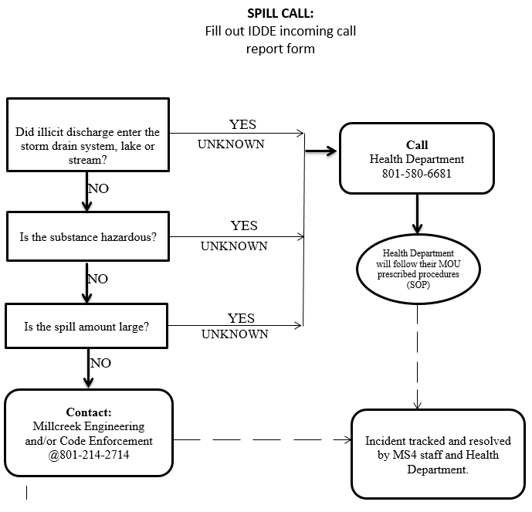

PART III. DRY WEATHER SCREENING PLAN

INTRODUCTION/PURPOSE:
Dry weather screening is an important component of the overall IDDE plan to identify, characterize, and remove illicit discharges. This consists of inspecting all stormwater outfalls that discharge to waters of the State in compliance with Millcreek’s stormwater discharge permit. This plan will be developed and implemented to define the outfall screening priority, screening parameters and procedures.

OUTFALL SCREENING PRIORITY:
Each outfall will be prioritized based on different land use types as well as determining areas with the highest risk of pollutant run-off. The following criteria will be used to determine high, medium, and low outfall priorities:

- High Priority:
- Areas with older infrastructure
- Industrial areas
- Areas with a history of illegal discharges
- Areas with onsite sewage disposal systems, older sewer lines, history of overflows and cross-connections
- Areas discharging to waters listed on a State TMDL list

- Medium Priority:
- Outfalls discharging to impaired water bodies (Clean Water Act Section 303d)
- Commercial areas

- Low Priority:
- Residential areas
- Areas that do not drain or are not connected to Millcreek’s storm drain system.

SCREENING PARAMETERS:
Dry weather screening will take place during dry periods of weather conditions. Outfalls will be inspected for the following physical characteristics:

- Odor – Odor may indicate the source of contamination. For example, industrial discharges may produce an odor that would suggest contamination from oil, gasoline, chemicals, or solvents. Food production industries may potentially discharge organic substances into drainage facilities associated with a pungent odor.

- Color – Color may also indicate sources of illicit discharge. For example, brown, gray, or black or produced from industrial sources. Meat processing may produce a reddish-brown color, and plating mills may produce a yellowish color.
- Clarity – Dry weather discharges that are cloudy may result from concrete washout activity or stone milling and related industries. Sanitary wastewater may also be cloudy.

- Floatable Matter – Illicit discharges may also have floatable matter that could be traced to possible sources.

- Deposits and Stains – Evidence of past illicit discharges can be manifested on the surfaces of outfall structures as stains and deposits. However, some deposits (i.e. calcium) not caused by an illicit discharge may occur from natural water sources and hardness properties.

- Vegetation – Vegetation around outfall structures is another possible indicator or illicit discharges. Minimal and contaminated plants may be a result of low ph levels (highly acidic). Excessive plant growth may be the result of too many nutrients (excess amounts of phosphorous and nitrogen).

SCREENING PROCEDURE:

- Conduct outfall inspections during periods of low ground water and dry weather (no precipitation in the last 72 hours).

- Request assistance if unsafe conditions (poor access to site, steep slopes, confined spaces, transient camps, high discharge rates, etc.) are present. Perform the inspection only if it is safe to do so.

- Wear appropriate personal protective equipment and safety clothing.

- Properly hydrate and carry water as needed; Protect yourself from the elements with sunscreen, hat, and insect spray as needed; Be familiar and aware of areas with poison ivy.

- Document all inspections on the Dry Weather Screening Inspection Report (Exhibit 2).

MAPPING:

- Maintain and update storm drain system map with outfalls, pipes, and inlet locations.

Exhibit 1
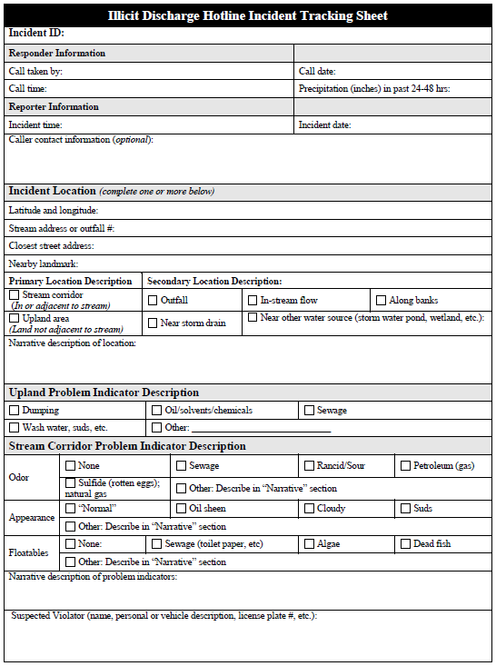

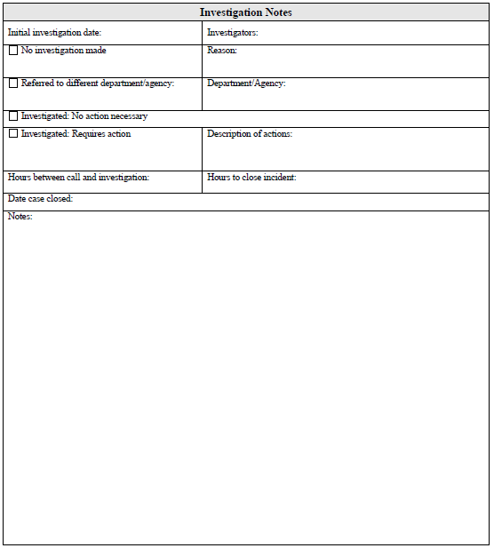

Exhibit 2

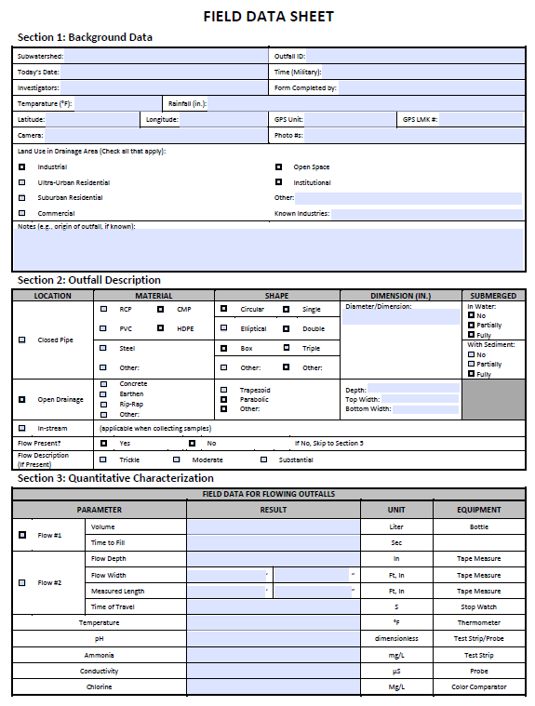

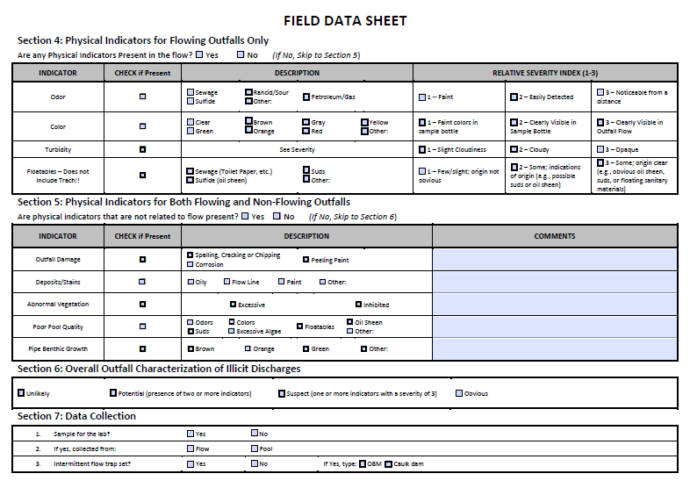

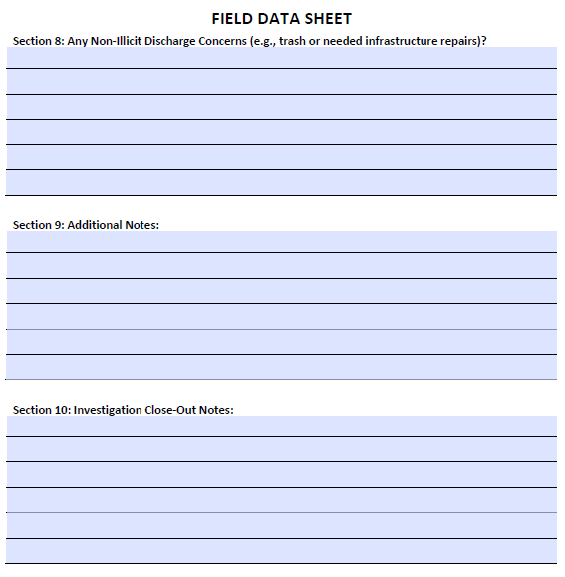

Acronyms
- BMP: Best Management Practice
- SLCo HD: Salt Lake County Health Department
- UPDES: Utah Pollutant Discharge Elimination System
- RSI: Registered Storm water Inspector
- EPA: Environmental Protection Agency
- RSR: Registered Storm water Reviewer
- MS4: Municipal Separate Storm Sewer System
- NOV: Notice of Violation
- Owner: The party responsible for all construction operations and meeting all permit requirements
- Millcreek: City of Millcreek
- SOP: Standard Operating Procedure
- SWPPP: Storm water Pollution Prevention Plan
- UDEQ: Utah Department of Environmental Quality

Support Functions or documents
  - Millcreek Planning & Development Services
  - Millcreek Engineering
  - Stormwater Maintenance Agreement
  - Inspection Report
  - Latest computer tracking and record-keeping system

References:
  - Utah Department of Environment Quality: General Permit for Storm water Discharges Associated with Municipal Separate Storm Sewer Systems (MS4s), Authorization to Discharge under the UPDES Discharge Permit – Jordan Valley Municipal permit UTS0000001
  - Millcreek Ordinances Chapter 17.22, Storm water Part III – Post Construction
  - International Building Code and International Residential Code (most recent)

APPENDIX D CONSTRUCTION SITE STORMWATER RUNOFF CONTROL PROGRAM
Pre-Construction, Pre-SWPPP & SWPPP Review Site Inspections & Enforcement Response SOP
DWQ Construction Stormwater Inspection Form
https://documents.deq.utah.gov/water-quality/stormwater/construction/DWQ-2022-013274.pdf

Pre-Construction, Pre-SWPPP & SWPPP Review,
Site Inspections & Enforcement Response
Standard Operating Procedure
PURPOSE:
Outline the procedures and responsibilities for meeting the construction sediment and erosion control requirements in Millcreek’s storm water discharge permit for Millcreek personnel. The storm water permit requirements apply for construction activities that:
- Disturb one acre or more of land,
- Disturb less than one acre of land, but are part of larger common plan of development that disturb one acre or more, or
- Disturb land of any size if the site is adjacent (within 100ft) to regulated wetlands or surface waters or located in the Salt Lake City watershed.

PROCEDURE:
- Permit Application
  - Owner obtains a Storm water Discharge Permit Associated with Construction Activities from the UDEQ. The UDEQ construction permit application and related guidance are on the UDEQ website at:
https://deq.utah.gov/legacy/permits/water-quality/utah-pollutant-discharge-elimination-system/storm-water-general-construction.htm
  - Owner completes and submits a Permit Application to Millcreek. The Millcreek permit application and related information are on the Millcreek website at:
https://millcreek.us/planning-zoning-permits/
  - The application must designate the parties responsible for complying with the Millcreek requirements. The Owner will submit a signed copy of UDEQ NOI permit with Development Permit Application.
  - Owner prepares and submits a SWPPP that includes site plans and construction details for proposed Best Management Practices (BMPs) to be used for erosion and sediment control on the site during construction. The State of Utah Department of Environmental Quality construction permit application and SWPPP requirements are on the State of Utah DEQ website at:
https://deq.utah.gov/legacy/permits/water-quality/utah-pollutant-discharge-elimination-system/storm-water-general-construction.htm

- SWPPP Review and Approval
  - Millcreek (RSR or Equiv.) reviews the SWPPP and associated information for compliance with the Jordan Valley Municipal MS4 permit UTS0000001 and Millcreek Services Standards and Construction Specifications, by making a site visit during the planning application review process to review the site and the proposed construction planned.
  - Millcreek (RSR or Equiv.) completes the pre-construction SWPPP Review, which includes review of the site design, the planned operation at the construction site, planned BMP’s during the construction phase, and the planned BMP’s to be used to manage runoff created after development. Incorporated into the review procedures are considerations for potential water quality impacts and evaluation of opportunities for the use of LID and Green Infrastructure, and if applicable encourage such BMP’s to be incorporated into the site design. Identify priority construction sites, including those sites which discharge directly or immediately upstream of the waters of the State or within the Salt Lake City Watershed, which shall include the use of a Check list.
  - Millcreek (RSR or Equiv.) will inform the applicant in writing of any deficiencies in the SWPPP and ensure that the applicant responds to and addresses those deficiencies before the SWPPP is approved and any permits are issued for the construction.
  - The Millcreek Reviewer(s) will verify that the ownership and maintenance responsibilities for permanent (long term) BMPs are understood by the Owner and recorded against the property in a Document required by 17.22 of Millcreek Ordinance, known as a Storm Water Maintenance Agreement and Management plan (SWMA & SWMP-See Attachment B) as part of the subdivision or other required approval being recorded and prior to permits being issued for Construction.

- Permit approval and issuance
  - Once the SWPPP is reviewed and meets the Millcreek’s requirements, the Reviewer uploads a copy of the approved SWPPP and associated documents into the Permit for the applicant into Millcreek’s database.
  - The Plans Examiner stamps & signs the plans for approval under the grading review portion of the Development Application (electronically or wet stamp), enters the quantities of cut and fill to be permitted, along with the area to be disturbed for permitting under the SWPPP land disturbance permit into the database.
  - Administrative staff confirms approval, collects the applicable fees, and issues Millcreek Permit.

- Pre-Construction Meeting: To be held at Millcreek City Hall and/or on site after BMP’s are installed and prior to groundbreaking.
  - Required Attendees
    - Owners Special Construction Inspector
    - Owner/Applicant
    - Owners Construction Supervisor and Foreman
    - Owners Special Inspector - SWPPP (third party if contracted)
    - Millcreek Inspector, RSI
    - Millcreek Stormwater Engineer or Traffic Engineer
    - Millcreek Building Inspection Supervisor
    - Other Millcreek Officials as deemed necessary
  - Owner provides evidence that the person responsible for supervising and inspecting installation and maintenance of BMPs for the duration of the project is a certified RSI (or equivalent) that has been trained in a program acceptable to Millcreek.
  - Owner provides documentation that SWPPP has been approved by Millcreek Services (to be maintained on site).
  - Owner provides copies of storm water permits for construction issued by the State of Utah DEQ and Millcreek Services (to be maintained on site).
  - Millcreek Stormwater Inspector explains the storm water requirements:
    - Expectations and Requirements for erosion and sediment control practices and Enforcement consequences in accordance with 17.22 of Millcreek Ordinance.
    - That the SWPPP shall remain an approved SWPPP contingent on the owner/ operator updating the SWPPP to reflect changes in the BMPs as those changes become necessary.
    - Requirements for maintaining a certified storm water inspector on the project.
    - Enforcement Procedures for storm water violations – (see attachment A for Enforcement Procedure).
    - Annual renewal requirements for the State of Utah and Millcreek Stormwater Discharge Permit.
    - The inspection checklist that will be used by Millcreek Services or approve/agree to use checklist form proposed by owner/operator.
    - Any additional documents that maybe required before the issuance of the Millcreek’s permit (if the permit has not been issued), such as 404 permits, wetland or floodplain permits, etc.
    - Requirements and forms for transfer of ownership and Notice of Termination of permit.

- Inspections
  - Owner always maintains a copy of the approved SWPPP onsite . The SWPPP will be maintained and updated per Millcreek requirements and made available to Millcreek, The State of Utah and EPA inspectors upon request.
  - Owner installs and maintains all BMPs as specified in the approved SWPPP.
  - Owner updates SWPPP, including the site map and any procedures, to include any changes in BMPs.
  - Owner inspects all BMPs every 7 days or every 14 days and immediately after any significant rainfall (0.5 or greater) and snowfall and snowmelt or as required by SWPPP.
  - Owner maintains a record of inspections records of BMPs onsite with the SWPPP. Copies of records of inspections will be made available to the Millcreek Inspectors at the time of their storm event and other scheduled and none scheduled inspections.
  - Owner keeps an onsite copy of the certification in erosion and sediment control for the person responsible for supervising installation and maintenance of sediment and erosion control practices.
  - Owner’s Inspector inspects the erosion and sediment BMPs for compliance with the approved SWPPP. The Millcreek Inspector meets on the site with the erosion and sediment control supervisor to inspect the site (using the State Construction Storm Water inspection form) in accordance with the Approved SWPPP and address any changes or improvements to the installed BMPs. At the same time, the Millcreek Inspector reviews the inspection records and revisions to the SWPPP.
  - Owner’s Inspector documents inspections in writing using Erosion and Sediment Control Field Inspection Report approved with the SWPPP
  - The Millcreek Inspector discusses all inspections, penalties, and fines with the Construction Inspection Supervisor, including those immediately after any significant rainfall (0.5 or greater) and snowfall and snowmelt. The Millcreek Inspector schedules, enters inspections and discussions into the data base.
  - The Millcreek Stormwater Inspector reports all corrective actions and issued fines, Notice of Violations, etc. to the Millcreek Storm Water Engineer/Program Manager.
  - Millcreek Development Services Administrative staff collects and files hard copies of the active SWPPP documents and permits in a central location in the database.
  - The Millcreek Stormwater Engineer responds to storm water-related requests and complaints submitted by the public. The complaints are forwarded to the correct division and or agency (when applicable). The complaints are entered tracked applicable agency or Millcreek Services as required.

- Change of Ownership/Transfer of Permit
  - Owner submits transfer of ownership forms to Millcreek Services and the State of Utah DEQ when there is a change in ownership of the site or project.
  - Millcreek Inspector ensures that transfer of ownership application and Notice of Termination forms are submitted by the Owner. He signs the forms submitted, completes field inspections and reports to the Millcreek Stormwater Engineer, findings of (NOT) Notice of Termination inspection.
  - Millcreek Stormwater Engineer and/or Inspector records changes or project inactivation or Termination on the State of Utah DEQ Administration Access Stormwater Permits page.

- Project Closeout
  - Owner submits Notice of Termination (NOT) forms to the Millcreek and UDEQ when the project is complete (70% Stabilized).
  - Owner provides evidence that the Notice of Termination application has been submitted to UDEQ to the Millcreek Inspector.
  - Owner prepares and submits to the Millcreek Construction Inspection Supervisor a certification signed by a Professional Engineer verifying that the permanent BMPs have been installed as per approved plans and specifications (when applicable). The Construction Inspection Supervisor uploads the certification in the latest computer software project file and sends a copy to the Millcreek Stormwater Program Manager.
  - The Site Project Manager and Millcreek Inspector inspect the permanent BMPs and final stabilization prior to deactivation of the Millcreek Building and or Grading permits by the permitted.
  - Millcreek Inspector Certifies in writing that all requirements for construction acceptance have been met and files the final documents into the database.
  - Millcreek Inspector submits Notice of Termination (verbal or written) to the Millcreek Stormwater Engineer/Program Manager.

- Violations and Enforcement
  - The Millcreek Inspector initiates enforcement actions in accordance with Enforcement Response Plan (attachment 2) in response to actual or potential waste or sediment discharges to the storm drain system.
  - The Millcreek Inspector provides information for possible follow-up action to the Millcreek Construction Inspection Supervisor or to the Salt Lake County Health Department.
  - The Millcreek Inspector or Supervisor or the Salt Lake County Health Department staff will issue NOVs, penalty assessments or takes other actions per Enforcement Response Plan or turn the violation over to Millcreek’s Attorney.

(Attachment A)
ENFORCEMENT RESPONSE PLAN - Construction Activity
PURPOSE:
Millcreek Services is required to implement State and Federal storm water regulations for construction activities in accordance with the requirements of the storm water discharge permit issued by the State of Utah Department of Environmental Quality. The regulations require the owners or operators of construction activities that disturb one acre or more of land (including activities on less than one acre if part of a common plan of development) to obtain permits from both Millcreek and the UDEQ. A Millcreek grading permit is also required for construction activities of any size that may affect water quality. To ensure that construction activities follow the regulatory requirements, enforcement provisions are included in the Millcreek Ordinances. Millcreek uses this Enforcement Response Plan and the attached Enforcement Response Guide to ensure enforcement actions are conducted in accordance with regulations and are applied in a consistent manner. The Millcreek objectives are to achieve compliance as quickly as possible and to make sure that violations do not continue.
LEGAL AUTHORITY:
The legal authority for enforcement of the storm water requirements is contained within the Millcreek Ordinances Chapter 17.22, Storm water Illicit Discharges and Permit Requirements, Section 17.22.180 Enforcement and Penalties. The Ordinance describes the types of enforcement actions that can be applied to violations of the requirements. The State of Utah, Federal Clean Water Act of 1987 and the Storm water Phase I regulations (40CFR122) also provide legal authority for the Millcreek Storm Water Quality Program.
RESPONSIBILITIES:
The Mayor or the Mayor’s designee are the responsible officials for all enforcement actions outlined in the Ordinance. For the purposes of construction activities, the Mayors designees are the following positions in the Millcreek Department:
- Millcreek City Manager
- Millcreek City Engineer
- Millcreek City Stormwater Engineer/ Program Manager
- Other positions that have authority to enforce Ordinance provisions are Director of City Services, Code Enforcement Officers, the Chief Building Official, Building Code Inspectors, and the Salt Lake County Health Department.
If litigation is necessary, enforcement will become the responsibility of the Millcreek District Attorney’s Office. Some or all of these positions may be involved in determining the seriousness of specific violations, the type of enforcement action to be taken and the appropriateness and timing of escalating enforcement.

ENFORCEMENT ACTIONS:
The Ordinance provides the authority for specific actions to deal with the enforcement of violations. The purpose of these enforcement actions is to bring the violator back into compliance as quickly as possible and minimize the negative impacts on the storm water system, surface waters and the public.
- The types of enforcement actions include:
  - COMPLIANCE ORDER – This is a written notification served to the owner/operator directing them that there is work that is out of compliance with the approved Storm water pollution prevention plans, or other development approved plans. The notice is posted on the site, work can continue for the time limit identified on the order to correct the deficiencies identified. Failure to correct the identified deficiencies will result in a STOP WORK ORDER being issued.
  - STOP WORK ORDER – This is a written notification served to the owner/operator directing them to stop work immediately. The notice is also posted on the construction site. Work can only be resumed after the conditions and requirements of the stop work order have been met. Copies of the stop work order are included in the project inspection files.
  - NOTICE OF VIOLATION (NOV) - This is formal written notification of violation(s) (Exhibit 1) and an official record of the violations and any remedies required by Millcreek. The time frame for responding to an NOV will be based on the seriousness of the violation and whether immediate actions are required to address imminent or ongoing violations. The NOV shall state the nature of the violation(s) and may refer to the specific section of the Ordinance or the Utah Clean Water Act that has been violated. The NOV is sent via certified mail or personal delivery.
  - REFERRAL TO CODE ENFORECMENT – PUBLIC NUISANCE – This is an action that is taken in response to a threatened discharge or public nuisance conditions that are not specifically related to construction requirements.
  - REFERRAL TO MILLCREEK DISTRICT ATTORNEY - This action is taken in response to conditions that are a threat to public health, safety or welfare and are not corrected immediately by the owner/operator.
  - REVOCATION OF PERMIT - Based on the seriousness of the violations and responsiveness of the permitted, Millcreek may revoke the storm water permit and require that the permitted resubmit a permit application and revised SWPPP that addresses and remedies the cause of the violations.
  - ABATEMENT- Whenever a violation is identified which will result in an immediate danger to public health or safety and the violation is not immediately corrected by the responsible party, Millcreek and Salt Lake County Health Department can take whatever measures are necessary to abate the violation. The cost of the abatement shall be charged to the responsible party.

- PENALTY AND FINES:
  - Whenever a Violation is identified which violates Millcreek Ordinances17.22, The State of Utah Federal Clean water Act of 1987 or the Storm water Phase I regulations (40CFR122) for Millcreek Storm Water Quality Program, the Inspectors in the field shall determine whether to issue a penalty or fine (fine schedule can be found here: https://millcreekut.files.wordpress.com/2018/02/2018-fee-schedule.pdf) in accordance with requirements of the SWPPP or Common plan of Development permit (when applicable) or in accordance with this document and/or to contact the Salt Lake County Health Department Emergency IDDE hot line (801) 580-6681 for sampling and testing for egregious Acts.
- LEVEL OF ENFORCEMENT AND ESCALATION:
  - The following guidelines are considered in determining the level of enforcement and the need to escalate enforcement:
    - Whether or not there are or have been recurring or chronic violations.
    - The diligence of the owner/operator in responding to and solving the problem which caused the violation(s) and how quickly compliance is achieved.
    - Seriousness of the violation. For example, pollutants entering the storm drain or surface waters are more significant than pollutants that have a potential to leave the site but are currently contained. Pollutants that endanger the public, workers, or the environment due to lack of proper BMPs or poor BMP maintenance are serious problems whether or not they have left the site. Serious violations must be addressed immediately to prevent additional problems and to keep the Millcreek in compliance with its Storm water permit requirements. Less serious violations require enforcement that rapidly brings the construction activities into compliance and keeps them in compliance.
    - Economic benefit – If the violation has resulted in avoidance of costs to comply with regulatory requirements or operate in an environmentally responsible way, this can be considered when determining enforcement actions and penalties.
STORMWATER QUALITY PROGRAM
Construction Activities Enforcement Response Guide

ENFORCEMENT RESPONSE
Violations of the construction activities in the storm water requirements generally fall into the following areas:
- Administrative Violations: Millcreek or State permits not current, Working without Millcreek or State permit, SWPPP not on site, SWPPP not up to date, No designated or certified on-site erosion control specialist, Storm water inspection records missing, not completed according to requirements or not up to date, Millcreek and/or State Notice of Inactivation not submitted, Millcreek and/or State Transfer of Ownership not submitted.
- Best Management Practices (BMPs) Violations with no discharge off of site: BMPs not maintained in accordance with best practices or SWPPP, Improperly stored materials on site, BMPs in use on the site not shown/not covered in SWPPP, Site changes requiring new or modified BMPs not covered in SWPPP, Improperly maintained or located vehicle storage or maintenance areas.
- Best Management Practices (BMPs) Violations with discharge from site: Sediment or other pollutants leaving site; potential discharge to storm drain Sediment or other pollutants leaving site, discharge to storm drain or channel.
Each of these violations may result in different enforcement actions, a series of enforcement actions, or a combination of enforcement actions, depending on the severity and duration of the violation. In addition, the following will be evaluated when determining appropriate actions or escalating enforcement for continued violations:
- Magnitude of the violation (type and severity)
- Duration of the violation
- Effect of the violation on the environment and public health
- Effect of the violation on surface waters
- Economic benefit realized because of noncompliance
VIOLATIONS AND ENFORCEMENT ACTIONS
- Millcreek or State permits not current

Compliance Order: Millcreek Inspector gives owner/operator a Compliance Order with schedule to obtain updated permit(s). The Millcreek Inspector documents the date and conditions creating the Compliance Order in inspection records.
Stop Work Order: Millcreek Inspector issues Stop Work Order if permits are not obtained within time frame. Date and conditions of Stop Work Order are recorded on the Stop Work order and in database.
Referral to Millcreek Attorney: If work continues at the site, Millcreek is to be informed and will refer this issue to Millcreek District Attorney for action.
NOV and penalty assessment: Millcreek prepares and issues an NOV with a compliance schedule and penalty assessment (if appropriate) if there is no response to the Stop Work Order or permits are not obtained in a timely manner.

- Working without Millcreek or State permit

Stop Work Order: Inspector issues Stop Work Order. Date and conditions of Stop Work Order are recorded in inspection records. Inspector refers case to Millcreek Services for further action.
NOV and penalty assessment: Millcreek prepares and issues an NOV with a compliance schedule and penalty assessment (if appropriate) if there is no response to the Stop Work Order or permits are not obtained in a timely manner.
Referral to Millcreek Attorney: If work continues at the site, Millcreek is to be informed and will refer this issue to Millcreek District Attorney for action.

- Storm water Pollution Prevention Plan not on site or Storm water Pollution Plan not up to date

Compliance Order: Millcreek Inspector gives owner/operator a Compliance Order with schedule for correcting SWPPP deficiencies. The Inspector documents the date and conditions of Compliance Order in writing and uploads into database.
NOV and penalty assessment: Millcreek Services prepares and issues an NOV and penalty assessment (if appropriate) if there is no response to Compliance Order or SWPPP deficiencies are not corrected in a timely manner. Also see Stop Work Order.
Stop Work Order: Millcreek Inspector can issue Stop Work Order if there is no response to the Compliance Order and/or NOV.
Referral to Millcreek Attorney: If work continues at the site, Millcreek is to be informed and will refer this issue to Millcreek District Attorney for further action.

- No designated or certified on-site erosion control specialist Storm water inspection records missing, not completed or not up to date
Compliance Order: Millcreek Inspector gives owner/operator a Compliance Order with schedule for correcting SWPPP deficiencies. The Inspector documents the date and conditions of Compliance Order in writing and uploads into database.
NOV and penalty assessment: Millcreek Services prepares and issues an NOV and penalty assessment (if appropriate) if there is no response to Compliance Order or SWPPP deficiencies are not corrected in a timely manner. Also see Stop Work Order.
Stop Work Order: Millcreek Inspector can issue Stop Work Order if there is no response to the Compliance Order and/or NOV.
Referral to Millcreek Attorney: If work continues at the site, Millcreek is to be informed and will refer this issue to Millcreek District Attorney for further action.

- Millcreek Services and/or State Notice of Inactivation not submitted

Compliance Order: Millcreek Inspector gives owner/operator a Compliance Order with schedule for correcting SWPPP deficiencies. The Inspector documents the date and conditions of Compliance Order in writing and uploads into database.
NOV and penalty assessment: Millcreek Services prepares and issues an NOV and penalty assessment (if appropriate) if there is no response to Compliance Order or SWPPP deficiencies are not corrected in a timely manner. Also see Stop Work Order.
Penalty Assessment: Millcreek Services prepares and issues a penalty assessment if NOV is not complied with.
Revoke Permit: Permit is terminated by Millcreek Services if NOV is not complied with
Referral to Millcreek Attorney: If work continues at the site, Millcreek is to be informed and will refer this issue to Millcreek District Attorney for action.

- Millcreek and/or State Transfer of Ownership not submitted

Compliance Order: Millcreek Inspector gives owner/operator a Compliance Order with schedule for correcting SWPPP deficiencies. The Inspector documents the date and conditions of Compliance Order in writing and uploads into database.
NOV and penalty assessment: Millcreek Services prepares and issues an NOV and compliance schedule if there is no response to Compliance Order or the violations are not corrected in a timely manner.
Stop Work Order: Millcreek Inspector can issue Stop Work Order if there is no response to the Compliance Order and/or NOV and work continues on site.
Referral to Millcreek Attorney: If work continues at the site, Millcreek is to be informed and will refer this issue to Millcreek District Attorney for action.

- Best Management Practices Violations – No Discharge from Site

NOV and Compliance schedule: Millcreek Inspector gives owner/operator a Compliance Order with schedule for correcting SWPPP deficiencies. The Inspector documents the date and conditions of Compliance Order in writing Violations are referred to Millcreek Services if violations are not corrected a NOV or Stop Work may be issued.
Stop Work Order: Millcreek Inspector can issue Stop Work Order if there is no response to the Compliance Order and/or NOV and work continues on site.
Penalty Assessment: Millcreek Services prepares and issues a penalty assessment if NOV or Stop Work Order is not complied with.
Revoke Permit: Millcreek Permit is terminated by Millcreek Services if violations continue.
Referral to Millcreek Attorney: If work continues at the site, Millcreek is to be informed and will refer this issue to Millcreek District Attorney for action.

- BMPs in use on the site not shown or not covered in SWPPP Site changes requiring new or modified BMPs not covered in SWPPP

Compliance Order: Millcreek Inspector gives owner/operator a Compliance Order with schedule for correcting SWPPP or BMP deficiencies. The Inspector documents the date and conditions of Compliance Order in writing and uploads into database
NOV and penalty assessment: Millcreek Services prepares and issues an NOV and penalty assessment (if appropriate) if there is no response to Compliance Order or SWPPP deficiencies are not corrected in a timely manner. Also see Stop Work Order.
Stop Work Order: Millcreek Inspector can issue Stop Work Order if there is no response to the Compliance Order and/or NOV.
Penalty Assessment: Millcreek Services prepares and issues a penalty assessment if NOV or Stop Work Order is not complied with.
Revoke Permit: Millcreek Permit is terminated by Millcreek Services if violations continue.
Referral to Millcreek Attorney: If work continues at the site, Millcreek is to be informed and will refer this issue to Millcreek District Attorney for action.

- Best Management Practices Violations – Discharge from Site Sediment or other pollutants leaving site; potential discharge to storm drain

NOV and penalty assessment: Millcreek Services prepares and issues an NOV and penalty assessment (if appropriate) if there is no response to Compliance Order or SWPPP deficiencies are not corrected in a timely manner. Also see Stop Work Order.
Stop Work Order: Millcreek Inspector can issue Stop Work Order if there is no response to the Compliance Order and/or NOV.
Penalty Assessment: Millcreek Services prepares and issues a penalty assessment if NOV or Stop Work Order is not complied with.
Revoke Permit: Millcreek Permit is terminated by Millcreek Services if violations continue.
Referral to Millcreek Attorney: If work continues at the site, Millcreek is to be informed and will refer this issue to Millcreek District Attorney for action.

- Sediment or other pollutants leaving site, discharge to storm drain or channel

Stop Work Order: Millcreek Inspector issues Stop Work Order, documents the violation and requires owner/operator to mitigate the problems immediately. Project Inspector consults with Millcreek Services on further actions.
Abatement: If the violation will result in an immediate danger to public health or safety and is not immediately corrected by the owner/operator, the inspector will document the situation and refer it to Millcreek Services and Millcreek Health Via the 24 Hotline, who will arrange for abatement of the violation. The cost of the abatement shall be charged to the owner/operator.
NOV and compliance schedule: If the discharge caused minimal impact or was quickly mitigated by the owner/operator, Millcreek Services will prepare and issue an NOV and compliance schedule.
Revoke Permit: Depending on the severity of the violation, the owner/operators permit may be revoked.
Penalty assessment: Millcreek Services will prepare and issue penalty assessment, including costs of any abatement.
Referral to Millcreek Attorney: Depending on the permitted response, Millcreek Inspection Services or Health Department may refer the case to the Millcreek District Attorney for further action.

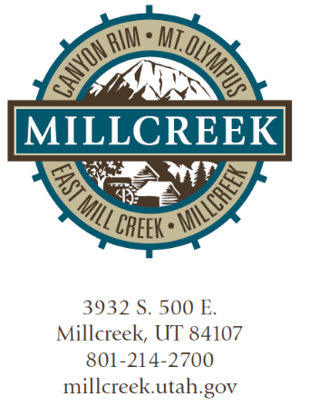
EXHIBIT 1
NOTICE OF VIOLATION
Date
Contact Name
Address1
Address2
RE: Notice of Violation - Stormwater
Permit for Construction Activity #Permit number
Dear Contact Name:
Pursuant to Chapter 17.22 of the Millcreek (Jordan Valley Municipal Permit UTS0000001) you are hereby notified of the following violations of the terms and conditions of the above-referenced permit:
During a monthly site inspection by the Township on xxxxxx it was found that your Stormwater Pollution Prevention Plan (SWPPP has not been updated to include recent changes in the site and in the Best Management Practices (BMPs) used on the site. The SWPPP must be correct and up to date per the requirements of your permit.
You have ___ days from receipt of this Notice to complete the following:
- Correct the violations and schedule an inspection with the Millcreek Inspector to confirm that the violations have been addressed.
- Submit a written description to the Millcreek Office of the steps you will take to ensure that there will be no future violations of the type listed above.

This Notice does not constitute a waiver or election by Millcreek to forego any civil or criminal action to seek penalties, fines, or other relief as it may deem appropriate under Chapter 17.22 of the Ordinance. Be advised that 17.22.180 of the Ordinance authorizes the imposition of penalties of up to $20,000.00 per day for each violation of the Ordinance. Nothing in this Notice shall be construed to preclude Millcreek of further action under the Ordinance for those violations cited herein or to relieve you from any responsibilities, liabilities, or penalties established pursuant to any applicable Federal, State or County laws or regulations. Please call if you have any questions. Millcreek appreciates your efforts to comply with the terms and conditions of your discharge permit and operate your construction activities in an environmentally responsible manner.

Sincerely,
Name
Millcreek SWPPP Inspector
cc: Name, Construction Inspection Supervisor
(Attachment B)
Long-term Stormwater Maintenance Agreement

When recorded, mail to:
Millcreek Recorder
3330 South 1300 East
Millcreek UT 84106

STORMWATER MAINTENANCE AGREEMENT

THIS STORMWATER MAINTENANCE AGREEMENT (this “Agreement”) is made and entered into this ____ day of __________________, 20__, by and between Millcreek, a municipal corporation of the State of Utah ( the “City”); and _______________________________________ (the “Owner”) whose address is __________________.
RECITALS
A. The City is authorized and required to regulate and control the disposition of storm and surface waters within the City, as set forth in the Millcreek Code of Ordinances 2017, as amended (“Code”), adopted pursuant to the Utah Water Quality Act, as set forth in Utah Code Ann § 19-5-101, et seq., as amended.
B. The Owner hereby represents and acknowledges that it is the owner in fee simple of certain real property more particularly described in exhibit “A,” attached hereto and incorporated herein by this reference (the “Property”), which property is subject to the regulations described above.
C. The Owner desires to build or develop the Property and/or to conduct certain regulated construction activities on the Property which will alter existing storm and surface water conditions on the Property and/or adjacent lands; and
D. In order to facilitate these anticipated developments to the Property, the Owner desires to build and maintain, at Owner's expense, storm and surface water management facilities, including structures, improvements, grading and drainage plans and/or vegetation to control the quantity and quality of the storm water (the “Stormwater Facilities”); and
E. The Stormwater Facilities are shown in the final site plan or subdivision approved for the Property, in any related engineering drawings, and in any amendments thereto, which plans and drawings are on file in the Millcreek Planning Services Office and are hereby incorporated herein by this reference (the “Development Plan”); and
F. A detailed description of the Stormwater Facilities, which includes the operation and routine maintenance procedures required to enable the Stormwater Facilities to perform their designed functions (the “Stormwater Management Plan”), is attached hereto as exhibit “B” and is incorporated herein by this reference; and
G. As a condition of the Development Plan approval, and as required by the Jordan Valley Municipalities Permit No. UTS000001 (“UPDES Permit”) from the State of Utah, Owner is required to enter into this Agreement establishing a means of documenting the execution of the Stormwater Maintenance Plan.
AGREEMENT
NOW, THEREFORE, in consideration of the benefits received and to be received by the Owner, its successors and assigns, as a result of the City’s approval of the Stormwater Maintenance Plan the parties agree as follows:
1. Construction of Stormwater Facilities. The Owner shall, at its sole cost and expense, construct the Stormwater Facilities in strict accordance with the Development Plan, specifications, and any amendments thereto which have been approved by the City or its agent.
2. Maintenance of Stormwater Facilities. The Owner shall, at its sole cost and expense, operate and maintain the Stormwater Facilities in strict accordance with the Stormwater Maintenance Plan. Owner's maintenance obligations shall be limited to structures, systems, and appurtenances on Owner’s land, including all system and appurtenance built to convey stormwater, as well as all structures, improvements, and vegetation provided solely to control the quantity and quality of the stormwater. Maintenance, for purposes of this Agreement, is defined as good working condition so that the Stormwater Facilities are performing their design functions. The Owner shall, at its sole cost and expense, perform all work necessary to keep the Stormwater Facilities in good working condition.
3. Annual Maintenance Report. The Owner shall, at its sole cost and expense, inspect the Stormwater Facilities and submit an inspection report and certification to City’s annually. The purpose of the inspection and certification is to assure safe and proper functioning of the Stormwater Facilities. The annual inspection shall cover all aspects of the Stormwater Facilities, including, but not limited to, the parking lots, structural improvements, berms, channels, outlet structure, pond areas, access roads, vegetation, landscaping, etc. Deficiencies shall be noted in the inspection report. The report shall also contain a certification as to whether adequate maintenance has been performed and whether the structural controls are operating as designed to protect water quality. The annual inspection report and certification shall be due by June 30, of each year and shall be in a form acceptable to the City.
4. Oversight Inspection Authority. The Owner hereby grants permission to the City, its authorized agents, and employees, to enter upon the Property and to inspect the Stormwater Facilities upon reasonable notice of not less than three business days to the Owner. The purpose of the inspection shall be to determine and ensure that the Stormwater Facilities are adequately maintained, are continuing to perform in an adequate manner, and are in compliance with all applicable laws, regulations, rules, and ordinances, as well as the Stormwater Maintenance Plan.
5. Notice of Deficiencies. If the City or its agent finds the Stormwater Facilities contain any defects or are not being maintained adequately, the City or its agent shall send the Owner written notice of the defects or deficiencies and provide the Owner with reasonable time to cure such defects or deficiencies, as provided in chapter 17.22 of the Code. Such notice shall be sent certified mail to the Owner’s address set forth above.
6. Owner to Make Repairs. The Owner shall, at its sole cost and expense, make such repairs, changes or modifications to the Stormwater Facilities as may be determined as reasonably necessary by the City or its agent within the required cure period to ensure the Stormwater Facilities are adequately maintained and continue to operate as designed and approved.
7. Corrective Action. In the event the Owner fails to adequately maintain the Stormwater Facilities in good working condition acceptable to the City agent, the City or its agent may proceed with any enforcement mechanism provided in chapter 7.22 of the Code. The City or its agent may also give written notice that the Stormwater Facilities will be disconnected from the City’s municipal separate storm sewer system. Any damage resulting from the disconnected system will be the Owner’s responsibility. It is expressly understood and agreed that neither the City nor its agent are under any obligation to maintain or repair the Stormwater Facilities, and in no event shall this Agreement be construed to impose any such obligation on the City or its agent. The actions described in this Section are in addition to and not in lieu of the legal remedies available to the City as provided by law for Owner's failure to remedy deficiencies or any other failure to perform under the terms and conditions of this Agreement.
8. Reimbursement of Costs. In the event the City or its agent, pursuant to this Agreement, incurs any costs, or expends any funds resulting from enforcement or cost for labor, use of equipment, supplies, materials, and the like related to storm drain disconnection from the City’s municipal separate storm sewer system, the Owner shall reimburse the City or its agent upon demand, within thirty (30) days of receipt thereof for all actual costs incurred by the City or it agent. After said thirty (30) days, such amount shall be deemed delinquent and shall be subject to interest at the rate of ten percent (10%) per annum. Owner shall also be liable for any collection costs, including attorney’s fees and court costs, incurred by the City or its agent in collection of delinquent payments. The Owner hereby authorizes the City or its agent to assess any of the above-described costs, if remained unpaid, by recording a lien against the Property.
9. Successors and Assigns. This Agreement shall be recorded in the office of the County Recorder and the covenants and agreements contained herein shall run with the land and whenever the Property shall be held, sold, conveyed or otherwise transferred, it shall be subject to the covenants, stipulations, agreements and provisions of this Agreement which shall apply to, bind and be obligatory upon the Owner hereto, its successors and assigns, and shall bind all present and subsequent owners of the Property described herein.
10. Severability Clause. The provisions of this Agreement shall be severable and if any phrase, clause, sentence or provision is declared unconstitutional, or the applicability thereof to the Owner, its successors and assigns, is held invalid, the remainder of this Agreement shall not be affected thereby.
11. Utah Law and Venue. This Agreement shall be interpreted under the laws of the State of Utah. Suits for any claims or for any breach or dispute arising out of this Agreement shall be maintained in the appropriate court of competent jurisdiction in Salt Lake County, Utah.
12. Indemnification. This Agreement imposes no liability of any kind whatsoever on the City or its agent. The Owner hereby agrees to indemnify and hold the City and its officers, employees, agents and representatives from and against all actions, claims, lawsuits, proceedings, liability, damages, losses, and expenses (including attorneys’ fees and court costs) that result from the performance of this agreement, but only to the extent the same are caused by any negligent or wrongful act or omissions of the Owner, and the Owner’s officers, employees, agents, and representatives.
13. Amendments. This Agreement shall not be modified except by written instrument executed by the City and the owner of the Property at the time of modification, and no modification shall be effective until recorded in the office of the County Recorder.
14. Subordination Requirement. If there is a lien, trust deed or other property interest Recorded against the Property, the trustee, lien holder, etc., shall be required to execute a subordination agreement or other acceptable recorded document agreeing to subordinate their interest to this Agreement.
15. Exhibits and Recitals. The recitals set forth above and all exhibits to this Agreement are incorporated herein to the same extent as if such items were set forth herein in their entirety within the body of this Agreement.

[SIGNATURE PAGE TO FOLLOW]
In witness whereof, the parties have signed and subscribed their names hereon and have caused this Agreement to be duly executed as of the day and year first set forth above.

OWNER

By: _____________________________________ Title: _____________________________________

By: ______________________________________ Title: _____________________________________

CITY

By: ____________________________________
Jeff Silvestrini, Mayor

ATTEST

____________________________________
Elyse Greiner, CMC City Recorder

CITY ACKNOWLEDGMENT

STATE OF UTAH )
:ss.
COUNTY OF SALT LAKE )

On the _____ day of ______, 20__, personally appeared before me ___________who being by me duly sworn, did say that he is the Mayor of Millcreek, a political subdivision of the State of Utah, and that said instrument was signed in behalf of the City by authority of its City Council and said Mayor acknowledged to me that the City executed the same.

__________________________________
NOTARY PUBLIC

My Commission Expires: ________________

Residing at: _________________________

OWNER ACKNOWLEDGMENT

STATE OF UTAH )
:ss.
COUNTY OF SALT LAKE )

On the _____ day of ______, 20__, personally appeared before me ______, who being by me duly sworn, did say that he is the Manager of ______________, a Utah limited liability company and that the foregoing instrument was duly authorized by the company at a lawful meeting held by authority of its operating agreement and signed in behalf of said company.

______________________________
NOTARY PUBLIC

My Commission Expires: ________________

Residing at: _________________________

Acronyms
- BMP: Best Management Practice
- SLCo HD: Salt Lake County Health Department
- UPDES: Utah Pollutant Discharge Elimination System
- RSI: Registered Storm water Inspector
- EPA: Environmental Protection Agency
- RSR: Registered Storm water Reviewer
- MS4: Municipal Separate Storm Sewer System
- NOV: Notice of Violation
- Owner: The party responsible for all construction operations and meeting all permit requirements
- SLCo: Millcreek
- SOP: Standard Operating Procedure
- SWPPP: Storm water Pollution Prevention Plan
- UDEQ: Utah Department of Environmental Quality

Support Functions or documents
- Millcreek Development Permit Application
- Notice of Termination of permit
- Application for Transfer or permit
- SWMP Review Checklist
- Latest computer permits tracking and record-keeping system (database-2015)
- Enforcement response plan

References:
- Utah Department of Environment Quality: General Permit for Storm water Discharges Associated with Municipal Separate Storm Sewer Systems (MS4s), Authorization to Discharge under the UPDES Discharge Permit – Jordan Valley Municipal permit UTS0000001
- Utah Department of Environment Quality: Storm water Discharges Associated with Construction Activity – Construction General Permit Application UPDES permit UTRC000000 and The Storm water Management Plan Preparation Guide
- Millcreek Ordinances Chapter 17.22, Storm water Illicit Discharges
- Millcreek Engineering: Public Improvement Design Standards and Construction Specifications (most recent revision)
- International Building Code and International Residential Code (most recent)

APPENDIX E LONG-TERM STORMWATER MANAGEMENT PROGRAM
Long-term Stormwater Management SOP

Long-term Stormwater Best Management Practice (BMP)
Maintenance and Inspection
Standard Operating Procedure
PURPOSE:
Outline the procedures for meeting the long-term stormwater management control requirements in Millcreek’s storm water discharge permit for Millcreek personnel. The storm water permit requirements apply to the following conditions with stormwater BMPs on the property:
- Property is larger than one acre or more of land,
- Property is less than one acre of land, but are part of larger common plan of development that disturb one acre or more, or
- At the discretion of Millcreek Stormwater personnel, any development with structural stormwater controls requiring ongoing operation and maintenance.

INSPECTION PROCEDURE: Owner shall conduct annual inspections (See Table 1 and Exhibit A for inspection schedule and report) of Stormwater BMP’s and submit to the Millcreek City Office by July 31st of each year. Millcreek will conduct BMP inspections once every 5 years for properties with maintenance agreements and annually for properties without maintenance agreements.
As applicable to each individual property, the inspection shall include the following items:

- Dumping Evidence: Evaluate catch basins, inlets, manholes, gutters etc. for the presence of stains from dumping or paints, thinners, oils, or other hazardous substances.
- Spill Evidence: Evaluate pavements and soils for spills, particularly for evidence of neglected spills.
- General Site Exposure: Evaluate materials, devices, and operations that are exposed to weather. Inspect to verify that BMPs are in place or that there are practices that will contain or minimize pollutants and pollutant sources. Look for uncontained waste material, oil, antifreeze, cleansers and other materials and chemicals that could seep into the ground, enter the storm drain system, or affect water quality.
- Stormwater Storage: Inspect for proper maintenance and condition of detention/retention ponds. Check for proper capacity, debris or sediment accumulation, and that overflow devices are in place and in good condition, etc.
- Inlets and catch basins: Inspect for proper maintenance and function of storm water inlets and catch basins. Inspect for pollutants, debris, and excessive amounts of dirt and sediment. Inlets, basins, and covers should be in good working order.
- Conveyance Systems: Inspect for proper maintenance, condition, and function of stormwater pipes, catch basins, swales, ditches, and other conveyances.
- Manholes: Inspect manholes for condition, debris, excessive amounts of sediment, proper maintenance, and function.
- Parking: Inspect parking areas for proper maintenance and condition. Inspect for pollutants, spills, etc. Pavement areas should indicate regular sweeping activity and maintenance.
- Waste Collection: Inspect for proper maintenance and function of waste collection facilities. Inspect for stains and leaks from containers. Ensure that lids are kept closed.
- Landscaping: Inspect for condition, maintenance, and function. Inspect for excessive debris. Ensure proper application of chemicals by looking for accumulation of excess fertilizers, herbicides, insecticides, etc.
- Pre-Treatment Devices: Inspect pre-treatment devices for proper maintenance and condition. Pre-treatment devices are devices such as hooded outlet cover (Snout), grease/sand interceptors, or other devices designed to remove pollutants from stormwater.
- Underground detention/retention systems: Inspect for proper maintenance and condition of Sumps, Class-V Injection Wells, and other similar underground devices designed to collect stormwater and percolate it to the ground.
- Flow Control Devices: Inspect for proper maintenance and function of Weirs, orifice plates and other similar flow control devices.
- Site Specific SOP Items: Certain land uses require site specific stormwater management SOP’s to ensure the quality of stormwater that is discharged from a site. Review site inspections for compliance with site SOPs. Evaluate the current SOP’s and modify, update, or amend them as needed.
- Other: Inspect other post construction stormwater items for proper function. This could include Pumps, Vaults, Backflow Devices, Bio-Filters, Bio-Retention Areas, Permeable Pavement, Green Roofs, etc.

TABLE 1
Storm water Management BMP
Schedule of Long-Term Maintenance Activities in Salt Lake County, Utah

Activity | Frequency | Notes
Inspection | Annually (private)  Once every 5 years (Millcreek) | It is recommended that the SMP Operation and  Maintenance Inspection Report, referenced by this agreement, be used as a guiding document. This annual inspection should be submitted to Salt Lake County upon completion.
Mowing and  maintenance of vegetation | Variable,  depending on vegetation and desired aesthetics | Landscaping and vegetation should be cared for  throughout the year to ensure that proper sediment removal and infiltration is maintained, and the Facilities remains aesthetically appealing.
Remove trash and  debris | As needed or  following each storm | Trash and debris should be removed regularly to ensure that the Facilities function properly and operate effectively. Trash often collects at inlet and outlet structures.
Inspect and  maintain inlet and  outlet structures | Annually | The inlet and outlet structures should be inspected for damage and proper operation.
Sediment removal | Variable (5-lO  years is typical) | The removal of sediment is necessary if the Facilities  begin to lose capacity or effectiveness.

EXHIBIT A
SMP OPERATION AND MAINTENANCE INSPECTION REPORT POST CONSTRUCTION PRIVATE
Site Name: |  |  |  |  | Date of Evaluation
Site Address:
Facility Contact information
 | NAME and MAILING ADDRESS |  |  |  |  |  |  |  | Phone |  |  |  | E− MAIL ADDRESS
SITE CONTACT:
INSPECTOR CONTACT:
BUSINESS TYPE: INSTITUTIONAL COMMERCIA L INDUSTRIAL OTHER________________________

Circle Business type
Are SOP’s for Storm water Post Construction Inspections implemented and available for review? YES NO
Circle Answer

Orifice Required for site YES NO Orifice Size: Hooded outlet cover (snout) Required for site YES NO
Circle Answers
Items Inspected |  | Checked |  | Maintenance Req’d? |  |  | Is there excessive accumulation of debris or sediment? |  |  |  | Observations and Remarks |  |  | Deadline for corrective action
 |  | Yes No |  | Yes |  | No | Yes |  |  | No
- Dumping Evidence
2. Spill Evidence
- General Site Exposure
4. Stormwater Storage condition and capacity
(detention/retention ponds)
5. Inlets and catch basins
6. Conveyance System
7. Manholes
8. Parking
9. Waste Collection
l 0. . Landscaping
11. Pre-Treatment devices
12. Sumps
13. Flow Control devices
14. Site Specific SOP Items
15. Other
Notes:
Print Name: |  |  |  |  |  |  |  | Date:
Signature: |  |  |  |  |  |  |  | Title or Position
Acronyms
- BMP: Best Management Practice
- SLCo HD: Salt Lake County Health Department
- UPDES: Utah Pollutant Discharge Elimination System
- RSI: Registered Storm water Inspector
- EPA: Environmental Protection Agency
- RSR: Registered Storm water Reviewer
- MS4: Municipal Separate Storm Sewer System
- NOV: Notice of Violation
- Owner: The party responsible for all construction operations and meeting all permit requirements
- Millcreek: City of Millcreek
- SOP: Standard Operating Procedure
- SWPPP: Storm water Pollution Prevention Plan
- UDEQ: Utah Department of Environmental Quality

Support Functions or documents
- Millcreek Planning & Development Services
- Millcreek Engineering
- Stormwater Maintenance Agreement
- Inspection Report
- Latest computer tracking and record-keeping system

References:
- Utah Department of Environment Quality: General Permit for Storm water Discharges Associated with Municipal Separate Storm Sewer Systems (MS4s), Authorization to Discharge under the UPDES Discharge Permit – Jordan Valley Municipal permit UTS0000001
- Millcreek Ordinances Chapter 17.22, Storm water Part III – Post Construction
- International Building Code and International Residential Code (most recent)

APPENDIX F REPORTING & RESPONSIBILITY
DWQ Annual Report Form
https://documents.deq.utah.gov/water-quality/stormwater/DWQ-2021-007004.pdf
Agreements/Responsibilities:
- UPDES Media Cost Share Agreement with Salt Lake County
- UPDES Accountability Document (in process)
- Interlocal Agreement with Salt Lake County for Public Work Services

