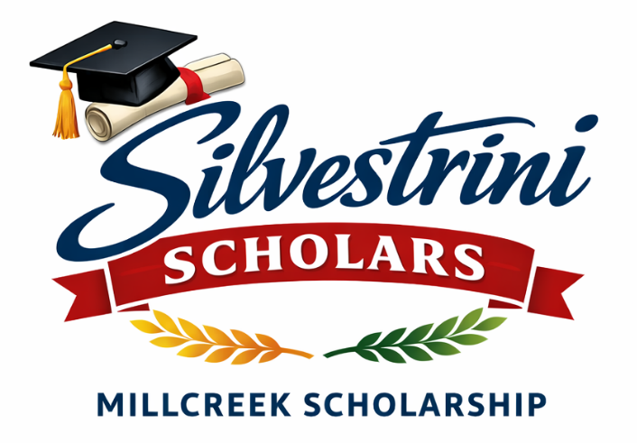
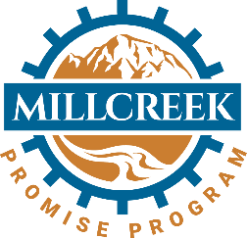


Silvestrini Scholars
Award: $1,000 for two students at each of the high schools that serve Millcreek students (Olympus, Skyline, Cottonwood, and Utah International Charter School)
Jeff Silvestrini was Millcreek’s first Mayor and created the Promise Program. He had a vision that all residents of Millcreek felt a sense of belonging and community. This scholarship is named after Millcreek’s first Mayor who wanted opportunity and wellness for all.
Eligibility:
- Must show proof of residence within the city of Millcreek
- Minimum GPA of 3.0 or higher to apply
- Obtain one letter of recommendation from a non-relative to be submitted with application
- Submit the following by April 10

- , 2026:
  - Completed application form
  - Proof of residence (piece of mail, ID, etc.)
  - Recommendation letter
  - Current transcript
- All applications can be submitted to Kristy Parajuli at kparajuli@millcreekut.gov

Millcreek Scholarship Application Form

Name:__________________________________________________
Street Address: __________________________________________
City and Zip:_____________________________________________
Phone:__________________________________________________
Email Address:_____________________________________________

What do you love most about living in Millcreek? (300 words or less)

What challenges have you overcome that have helped you prepare for college? (300 words or less)

What are ways that you have contributed or plan to contribute to your community? (500 words or less)

What are your post-secondary plans? (200 words or less)

